

Master Thesis

**SDN based Network Management in Emulated Environment**

|  |  |
| --- | --- |
| Submitted by: | Harshal Rajan Vaze |
| Matriculation no.: | 1269879 |
| First examiner: | Prof. Dr. Ulrich Trick |
| Second examiner: | Prof. Dr. Armin Lehmann |
| External supervisor: | Dr. Peter Gröschke |
| Date of start: | 01.05.2022 |
| Date of submission: |  |

Statement

I confirm that I have written this thesis on my own. No other sources were used except those referenced. Content which is taken literally or analogously from published or unpublished sources is identified as such. The drawings or figures of this work have been created by myself or are provided with an appropriate reference. This work has not been submitted in the same or similar form or to any other examination board.

_____________________________

Date, signature of the student

Content

1 Introduction 7

1.1 Aim and Motivation 7

1.2 Problem Statement 8

1.3 Thesis Structure 8

2 Theoretical Background 9

2.1 Software defined Networking 9

2.2 SDN Controllers 11

2.2.1 ONOS 16

2.2.2 ODL 16

2.2.3 Ryu 16

2.3 Software Switches 17

2.4 Virtual Emulated Environment 17

2.4.1 Mininet 17

2.4.2 GNS3 17

2.5 OpenFlow Protocol 18

3 Requirements Analysis 21

3.1 General Objectives 21

3.2 Work Plan 21

3.3 Previous Work 22

4 Realization 23

4.1 Installation of testbed 23

4.2 Implementation with GNS3 25

4.2.1 ONOS GUI 30

4.2.2 Creation and Installation of Flows 34

4.2.3 Creation and Installation of Intents 39

4.3 Implementation with Mininet 44

4.4 Problems identified 48

4.5 Use Case-1: Testing the ONOS Controller with Isolated L2 Overlay Networks 49

4.5.1 Introduction 49

4.5.2 Configuration and Working 53

4.6 Use Case-2: Testing the Network with Multiple ONOS Controllers 57

4.6.1 Introduction 57

4.6.2 Master Controllers with their Devices 60

4.6.3 Proof and validation of Link failover functioning 61

4.7 Use Case-3: Testing the ONOS Controller with IPv6 Addressing 63

4.7.1 Introduction 64

4.7.2 IPv6 over IPv4 tunnelling 68

4.8 Use Case-4: Integrating Software-defined Network with the Legacy Networks 71

4.8.1 Introduction 71

4.8.2 Configuration and Working 73

5 Summary and Perspectives 77

6 Abbreviations 78

7 References 80

8 Appendix 82

List of Figures

Figure 4. 1: Different virtual machines instances in VirtualBox 23

Figure 4. 2 End-points connected in VPLS 1 were successfully sending traffic to each other 56

Figure 4. 3 End-points connected in VPLS 2 were successfully sending traffic to each other 56

List of Tables

# Introduction

In this era of network virtualization and automation, many functions are moving towards virtualized and more centralized control, allowing for more dynamic functions and easier optimization. For networking it would mean spinning up the virtualized versions of traditional network functions allowing for more complex decisions making, automating the networks, and changing network configuration more efficiently.

Software-Defined Networking (SDN) is an approach to networking that uses software-based controllers and application programming interfaces (APIs) to communicate with underlying hardware infrastructure and direct traffic on a network. This method is different from that of traditional networks, where the configuration of dedicated hardware devices like Routers and Switches needs to be done node by node to control network traffic. SDN can create and control a virtual network or also control a traditional hardware via software. Because the control plane is software-based, SDN is much more flexible than traditional networking. It allows administrators to control and manage the network from a centralized user interface, without adding more hardware.

A SDN controller is an application in a software-defined networking architecture that manages flow control for improved network management and overall network performance. The SDN controller platform typically runs on a server and uses protocols to tell switches how to forward the packets. SDN controllers direct traffic according to forwarding policies that a network operator puts in place, thereby minimizing manual configurations for individual network devices. By taking the control plane off of the network hardware and running it instead as software, the centralized controller facilitates automated network management and makes it easier to integrate and administer various applications. In effect, the SDN controller serves as a sort of operating system (OS) for the network.

The SDN controller is the core of a software-defined network. It resides between network devices at one end of the network and applications at the other end. Any communication between applications and network devices must go through the controller. The SDN controller communicates with applications via northbound interfaces. The Open Networking Foundation (ONF) created a working group in 2013 focused specifically on northbound APIs and their development. The industry never settled on a standardized set, however, largely because application requirements vary so widely. Typically northbound RESTful APIs secured with TLS are used to push the configuration changes from the application to the SDN controller. The SDN controller talks with individual network devices using a southbound interface with the help of well-known OpenFlow protocol and other protocols such as NetConf, BGP, SNMP, etc. These southbound protocols allow the controller to configure network devices and choose the optimal network path for application traffic. OpenFlow was created by ONF in 2011 and latest version of OpenFlow protocol is OpenFlow 1.5.1.

## Aim and Motivation

There are various open-source SDN controllers developed by various groups of developers and are ready to be deployed and tested in the production environment. SDN controllers are primarily made to provide some policies and centralized managements for the networking layer, which will further allow inter-working configurations between the interfaces. Iptables, network namespaces, and Open vSwitch are components of the Linux kernel's L3 IP routing, Linux bridges, and SDN controller technologies. Being open-source controllers, not all of the available SDN controllers are developed on the same scale of mechanism in terms of supporting these various protocols, especially new versions of protocols and many of them are not developed yet to completely support all the services required for direct integration with the real world network. Therefore, the aim of this Master Thesis is to research and study different open-source SDN controllers in terms of their functionality with services and protocols.

After research, the aim would to build and setup the virtual network with network elements in the emulation software for testing the functionality of SDN controller. Further, to develop some use cases for demonstrating the services and protocols used in the network.

## Problem Statement

Due to advances in the Information and Communication Technology, the configuration and management of the network components becomes highly complex and time-consuming. A fundamental characteristic of SDN is the logically centralized, but physically distributed controller component. SDN offers to batch-configure automatically multiple components in one step, while the traditional way would mean to log into each device. Many operators struggle with the migration from IPv4 to IPv6, SDN with its centralized control and the possibility to reduce human error due to increased poses an opportunity to help make this migration easier. The controller maintains a global network view of the underlying forwarding infrastructure and programs the forwarding entries based on the policies defined by network services running on top of it. The traditional networking approach has very limited facilities to explore these aspects of networking and the goal would be to study these futuristic characteristics of networking.

## Thesis Structure

This thesis work is structured in five main chapters: chapter 1 gives the introduction to the topic and discusses the statement of the problem. Chapter 2 reviews the theoretical background knowledge of the topics associated with this thesis. Furthermore it also describes the in-depth information about the components used in this Thesis. In chapter 3, requirement analysis, the main objectives of the thesis are discussed focusing on question ‘which open-source SDN controllers are available to be tested in emulated environment?’. The realization of the implementation in different environments along with some use cases are presented and discussed in the chapter 4 named, realization. This chapter focuses on the question ‘how to implement suitable environment for testing the use cases?’. Finally, at end a summary, perspectives and future work are provided in chapter 5.

# Theoretical Background

## Software defined Networking

Dr. Martin Casado developed an architecture to separate control and forwarding functions of networking de-vices, migrating control to a centralized policy server. This architecture evolved to what is now known as Software Defined Networking (SDN) today. One of the first challenges was the need for a common South Bound Interface (SBI) protocol between the SDN Controller and the forwarding networking device. OpenFlow developed by the Open Networking Foundation (ONF) and is used over a secure channel (Transport Layer Security (TLS) over Transmission Control Protocol (TCP) port 6633 and 6653) to modify the group and flow tables in a OpenFlow networking device. OpenFlow has evolved to version 1.5.1.



Over the last few years, the need for a new approach to networking has been expressed to overcome the many issues associated with current networks. In particular, the main vision of the SDN approach is to simplify networking operations, optimize network management and introduce innovation and flexibility as compared to legacy networking architectures.

Network management is becoming more difficult and challenging given that the static and inflexible architecture of legacy networks is ill-suited to cope with today’s increasingly dynamic networking trends, and to meet the QoE requirements of modern users. This fact has fuelled the need for the enforcement of complex and high-level policies to adapt to current networking environments, and for the automation of network operations to reduce the tedious workload of low-level device configuration tasks.

The SDN initiative led by the Open Networking Foundation (ONF), on the other hand, proposes a new open architecture to address current networking challenges with the potential to facilitate the automation of network configurations , and better yet, fully program the network. Unlike the conventional distributed network architecture where network devices are closed and vertically-integrated bundling software with hardware, the SDN architecture raises the level of abstraction by separating the network data and control planes. That way, network devices become simple forwarding switches whereas all the control logic is centralized in software controllers providing a flexible programming framework for the development of specialized applications and for the deployment of new services. Such aspects of SDN are believed to simplify and improve network management by offering the possibility to innovate, customize behaviours and control the network according to high-level policies expressed as centralized programs, therefore bypassing the complexity of low-level network details and overcoming the fundamental architectural problems like high complexity and configuration. Added to these features is the ability of SDN to easily cope with the heterogeneity of the underlying infrastructure thanks to the SDN Southbound interface abstraction.

Data plane:

The data plane, also known as the forwarding plane, consists of a distributed set of forwarding network elements (mainly switches) in charge of forwarding packets. In the context of SDN, the control-to-data plane separation feature requires the data plane to be remotely accessible for software-based control via an open vendor-agnostic Southbound interface.

Both OpenFlow [24] and ForCES [25] are well-known candidate protocols for the Southbound interface. They both follow the basic principle of splitting the control plane and the forwarding plane in network elements and they both standardize the communication between the two planes. However, these solutions are different in many aspects, especially in terms of network architecture design. Standardized by IETF, ForCES (Forwarding and Control Element Separation) [25] introduced the separation between the control plane and the forwarding plane. In doing so, ForCES defines two logic entities that are logically kept in the same physical device: the Control Element (CE) and the Forwarding Element (FE). However, despite being a mature standard solution, the ForCES alternative did not gain widespread adoption by major router vendors. On the other hand, OpenFlow [24] received major attention in both the research community and the industry. Standardized by the ONF [23], it is considered as the first widely accepted communication protocol for the SDN Southbound interface. OpenFlow enables the control plane to specify in a centralized way the desired forwarding behaviour of the data plane. Such traffic forwarding decisions reflect the specified network control policies and are translated by controllers into actual packet forwarding rules populated in the flow tables of OpenFlow switches.

Control plane:

Regarded as the most fundamental building entity in SDN architecture, the control plane consists of a centralized software controller that is responsible for handling communications between network applications and devices through open interfaces. More specifically, SDN controllers translate the requirements of the application layer down to the underlying data plane elements and give relevant information up to SDN applications.

The SDN control layer is commonly referred to as the Network Operating System (NOS) as it supports the network control logic and provides the application layer with an abstracted view of the global network, which contains enough information to specify policies while hiding all implementation details. Typically, the control plane is logically centralized and yet implemented as a physically distributed system for scalability and reliability reasons as discussed in Sections III and IV. In a distributed SDN control configuration, East-Westbound APIs[40] are required to enable multiple SDN controllers to communicate with each other and exchange network information.

Despite the many attempts to standardize SDN protocols, there has been to date no standard for the East-West API which remains proprietary for each controller vendor. Although a number of East-Westbound communications happen only at the data-store level and do not require additional protocol specifics, it is becoming increasingly advisable to standardize that communication interface in order to provide wider interoperability between different controller technologies in different autonomous SDN networks.

On the other hand, an East-Westbound API standard requires advanced data distribution mechanisms and involves other special considerations. This brings about additional SDN challenges, some of which have been raised by the state-of the art distributed controller platforms discussed in Sections III and IV, but have yet to be fully addressed.

Application Plane:

The SDN application plane comprises SDN applications which are control programs designed to implement the network control logic and strategies. This higher-level plane interacts with the control plane via an open Northbound API. In doing so, SDN applications communicate their network requirements to the SDN controller which translates them into Southbound-specific commands and forwarding rules dictating the behaviour of the individual data plane devices. Routing, Traffic Engineering (TE), firewalls and load balancing are typical examples of common SDN applications running on top of existing controller platforms. In the context of SDN, applications leverage the decoupling of the application logic from the network hardware along with the logical centralization of the network control, to directly express the desired goals and policies in a centralized high-level manner without being tied to the implementation and state distribution details of the underlying networking infrastructure.

Concurrently, SDN applications make use of the abstracted network view exposed through the Northbound interface to consume the network services and functions provided by the control plane according to their specific purposes. That being said, the Northbound API implemented by SDN controllers can be regarded as a network abstraction interface to applications, easing network programmability, simplifying control and management tasks and allowing for innovation. In contrast to the Southbound API, the Northbound API is not supported by an accepted standard. Despite the broad variety of Northbound APIs adopted by the SDN community (see Figure 2), we can classify them into two main categories:

* The first set involves simple and primitive APIs that are directly linked to the internal services of the controller platform. These implementations include:
  + - Low-level ad-hoc APIs that are proprietary and tightly dependent on the controller platform. Such APIs are not considered as high-level abstractions as they allow developers to directly implement applications within the controller in a low-level manner. Deployed internally, these applications are tightly coupled with the controller and written in its native general-purpose language. NOX in C++ and POX in Python are typical examples of controllers that use their own basic sets of APIs.
    - APIs based on Web services such as the widely-used REST API. This group of programming interfaces enables independent external applications (Clients) to access the functions and services of the SDN controller (Server). These applications can be written in any programming language and are not run inside the bundle hosting the controller software. Floodlight is an example of an SDN controller that adopts an embedded Northbound API based on REST.
* The second category contains higher level APIs that rely on domain-specific programming languages such as Frenetic [41], Procera [42] and Pyretic [43] as an indirect way for applications to interact with the controller. These APIs are designed to raise the level of abstraction in order to allow for the flexible development of applications and for the specification of high-level network policies.

## SDN Controllers

Distributed SDN Control: Survey, Taxonomy and Challenges [1]

Point about multiple controller physical, logical separation [2]

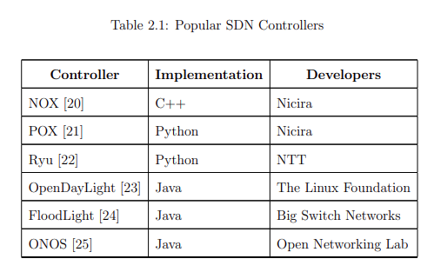

Despite the undeniable strengths of SDN, there have always been serious concerns about the ability to extend SDN to largescale networks. Some argue that these scalability limits are basically linked to the protocol standards being used for the implementation of SDN. OpenFlow [24] in particular, although recognized as a leading and widely-deployed SDN Southbound technology, is currently being rethought for potentially causing excessive overheads on switches (switch bottleneck). Scalable alternatives to the OpenFlow standard which propose to revisit the delegation of control between the controller and the switches with the aim of reducing the reliance on SDN the control plane, have been discussed in II-A. Another entirely different approach to addressing the SDN scalability and reliability challenges, which is advocated by the present paper, is to physically distribute the SDN control plane. This has led to a first categorization of existing controller platforms into centralized and distributed architectures.

Centralized SDN control

A physically-centralized control plane consisting of a single controller for the entire network is a theoretically perfect design choice in terms of simplicity. However, a single controller system may not keep up with the growth of the network. It is likely to become overwhelmed (controller bottleneck) while dealing with an increasing number of requests and concurrently struggling to achieve the same performance guarantees. Obviously, a centralized SDN controller does not meet the different requirements of large-scale real-world network deployments. Data Centers and Service Provider Networks are typical examples of such large-scale networks presenting different requirements in terms of scalability and reliability. More specifically, a Data Center Network involves tens of thousands of switching elements. Such a great number of forwarding elements which can grow at a fast pace is expected to generate a huge number of control events that are enough to overload a single centralized SDN controller [44, 45]. Studies conducted in [46] show important scalability implications (in terms of throughput) for centralized controller approaches. They demonstrate that multiple controllers should be used to scale the throughput of a centralized controller and meet the traffic characteristics within realistic data centers. Unlike data centers, Service Provider Networks are characterized by a modest number of network nodes. However, these nodes are usually geographically distributed making the diameter of these networks very large [44]. This entails a different type of controller scalability issues for centralized controller approaches, more specifically, high latencies. In addition to latency requirements, service provider networks have large numbers of flows that may generate overhead and bandwidth issues. In general, Wide Area Network (WAN) deployments typically impose strict resiliency requirements. In addition, they present higher propagation delays as compared to data center networks. Obviously, a centralized controller design in a SDWAN cannot achieve the desired failure resiliency and scaleout behaviors [47]. Several studies have emphasized the need for a distributed control plane in a SD-WAN architecture: They indeed focused on placing multiple controllers on real WAN topologies to benefit both control plane latency and faulttolerance [48, 49]. That said, the potential scalability, reliability and vulnerability concerns associated with centralized controller approaches have been further confirmed through studies [7, 50] on the behavior of state-of-the-art centralized SDN controllers such as NOX [51], Beacon [52] and Floodlight [53] in different networking environments.

In particular, NOX classic [51], the world’s first-generation OpenFlow controller with an event-based programming model, is believed to be limited in terms of throughput. Indeed, it cannot handle a large number of flows, namely a rate of 30k flow initiation events per second [7, 54]. Such a flow setup throughput may sound sufficient for an enterprise network, but, it could be arguable for data-center deployments with high flow initiation rates [46]. Improved versions of NOX have been consequently developed by the same community (Nicira Networks) such as NOX-MT [55] for better performance and POX [56] for a more developer-friendly environment. However, while none of these centralized designs is believed to meet the above scalability and reliability requirements of large-scale networks, they have gained greater prominence as they were widely used for research and educational purposes. Additionally, Floodlight [53] which is a very popular Javabased OpenFlow controller from Big Switch Networks, suffers from serious security and resiliency issues. For instance, Dhawan et al. [57] have reported that the centralized SDN controller is inherently susceptible to Denial-of-Service (DoS) attacks. Another subsequent version of Floodlight, called SEFloodlight, has therefore been released to overcome these problems by integrating security applications. However, despite the introduced security enhancements aimed at shielding the centralized controller, the latter remains a potential weakness compromising the whole network. In fact, the controller still maintains a single point of failure and bottlenecks even if its latest version is less vulnerable to malicious attacks. On the other hand, given its obvious performance and functionality advantages, the open-source Floodlight has been extensively used to build other SDN controller platforms supporting distributed architectures such as ONOS [58] and DISCO [59].

Distributed SDN control

Alternatively, physically-distributed control plane architectures have received increased research attention in recent years since they appeared as a potential solution to mitigate the issues brought about by centralized SDN architectures (poor scalability, Single Point of Failure (SPOF), performance bottlenecks, etc). As a result, various SDN control plane designs have been proposed in recent literature. Yet, we discern two main categories of distributed SDN control architectures based on the physical organization of SDN controllers: A flat SDN control architecture and a hierarchical SDN control architecture (see Figure 3).

1) Flat SDN control:

The flat structure implies the horizontal partitioning of the network into multiple areas, each of which is handled by a single controller in charge of managing a subset of SDN switches. There are several advantages to organizing controllers in such a flat style, including reduced control latency and improved resiliency. Onix [60], Hyperflow [61] and ONOS [58] are typical examples of flat physically-distributed controller platforms which are initially designed to improve control plane scalability through the use of multiple interconnected controllers sharing a global network-wide view and allowing for the development of centralized control applications. However, each of these contributions takes a different approach to distribute controller states and providing control plane scalability. For example, Onix provides a good scalability through additional partitioning and aggregation mechanisms. To be more specific, Onix partitions the NIB (Network Information Base) giving each controller instance responsibility for a subset of the NIB and it aggregates by making application reduce the fidelity of information before sharing it between other Onix instances within the cluster. Similar to Onix, each ONOS instance (composing the cluster) that is responsible for a subset of network devices holds a portion of the network view that is also represented in a graph. Different from Onix and ONOS, every controller in HyperFlow has the global network view, thus getting the illusion of control over the whole network. Yet, HyperFlow can be considered as a scalable option for specific policies in which a small number of network events affect the global network state. In that case, scalability is ensured by propagating these (less frequent) selected events through the event propagation system. Furthermore, different mechanisms are put in place by these distributed controller platforms to meet fault-tolerance and reliability requirements in the event of failures or attacks. Onix [60] uses different recovery mechanisms depending on the detected failures. Onix instance failure is most of the time handled by distributed coordination mechanisms among replicas whereas network element/link failures are under the full responsibility of applications developed atop Onix. Besides, Onix is assumed reliable when it comes to connectivity infrastructure failures as it can dedicate the failure recovery task to a separate management backbone that uses a multipathing protocol.

Likewise, Hyperflow [61] focuses on ensuring resiliency and fault tolerance as a means for achieving availability. When a controller failure is discovered by the failure detection mechanisms deployed by its publish/subscribe WheelFS [62] system, HyperFlow reconfigures the affected switches and redirects them to another nearby controller instance (from a neighbour’s site). Alongside this ability to tackle component failures, HyperFlow is resilient to network partitioning thanks to the partition tolerance property of WheelFS. In fact, in the presence of a network partitioning, WheelFS partitions continue to operate independently, thus favouring availability. Similarly, ONOS [58] considers fault-tolerance as a prerequisite for adopting SDN in Service Provider networks. ONOS’s distributed control plane guards against controller instance failures by connecting, from the onset, each SDN switch to more than one SDN controller; its master controller and other backup controllers (from other domains) that may take over in the wake of master controller failures. Load balancing mechanisms are also provided to balance the mastership of switches among the controllers of the cluster for scalability purposes. Besides, ONOS incorporates additional recovery protocols, such as the Anti-Entropy protocol [63], for healing from lost updates due to such controller crashes. Recent SDN controller platform solutions [64, 65, 66, 67, 68, 69] focused specifically on improving fault-tolerance in the distributed SDN control plane. Some of these works assumed a simplified flat design where the SDN control was centralized. However, since the main focus was placed at the fault-tolerance aspect, we believe that their ideas and their fault-tolerance approaches can be leveraged in the context of medium to large scale SDNs where the network control is physically distributed among multiple controllers.

In particular, Botelho et. al [70] developed a hybrid SDN controller architecture that combines both passive and active replication approaches for achieving control plane fault tolerance. SMaRtLight adopts a simple Floodlight [53]-based multi-controller design following OpenFlow 1.3, where one main controller (the primary) manages all network switches, and other controller replicas monitor the primary controller and serve as backups in case it fails. This variant of a traditional passive replication system relies on an external data store that is implemented using a modern active Replicated State Machine (RSM) built with a Paxoslike protocol (BFT-SMaRt [71]) to ensure fault-tolerance and strong consistency. This shared data store is used for storing the network and application state (the common global NIB) and also for coordinating fault detection and leader election operations between controller replicas that run a lease management algorithm.

In case of a failure of the primary controller, the elected backup controller starts reading the current state from the shared consistent data store in order to mitigate the cold-start (empty state) issue associated with traditional passive replication approaches, and thereby ensure a smoother transition to the new primary controller role. The limited feasibility of the deployed controller fault tolerance strategy is warranted by the limited scope of the SMaRtLight solution which is only intended for small to medium-sized SDN networks. On the other hand, in large-scale deployments, adopting a simplified Master-Slave approach, and more importantly, assuming a single main controller scheme where one controller replica must retrieve all the network state from the shared data store in failure scenarios, have major disadvantages in terms of increased latency and failover time.

Similarly, the Ravana controller platform proposal [66] addresses the issue of recovering from complete fail-stop controller crashes. It offers the abstraction of a fault-free centralized SDN controller to unmodified control applications which are relieved of the burden of handling controller failures. Accordingly, network programmers write application programs for a single main controller and the transparent masterslave Ravana protocol takes care of replicating, seamlessly and consistently, the control logic to other backup controllers for fault-tolerance. The Ravana approach deploys enhanced Replicated State Machine (RSM) techniques that are extended with switchside mechanisms to ensure that control messages are processed transactionally with ordered and exactly-once semantics even in the presence of failures. The three Ravana prototype components, namely the Ryu [72]-based controller runtime, the switch runtime, and the control channel interface, work cooperatively to guarantee the desired correctness and robustness properties of a fault-tolerant logically centralized SDN controller. More specifically, when the master controller crashes, the Ravana protocol detects the failure within a short failover time and elects the standby slave controller to take over using Zookeeper [73]-like failure detection and leader election mechanisms. The new leader finishes processing any logged events in order to catch up with the failed master controller state. Then, it registers with the affected switches in the role of the new master before proceeding with normal controller operations.

2) Hierarchical SDN control:

The hierarchical SDN control architecture assumes that the network control plane is vertically partitioned into multiple levels (layers) depending on the required services. According to [74], a hierarchical organization of the control plane can improve SDN scalability and performance. To improve scalability, Kandoo [31] assumes a hierarchical two-layer control structure that partitions control applications into local and global. Contrary to DevoFlow [28] and DIFANE [27], Kandoo proposes to reduce the overall stress on the control plane without the need to modify OpenFlow switches. Instead, it establishes a two-level hierarchical control plane, where frequent events occurring near the data path are handled by the bottom layer (local controllers with no interconnection running local applications) and non-local events requiring a network-wide view are handled by the top layer (a logically centralized root controller running non-local applications and managing local controllers).

Despite the obvious scalability advantages of such a control plane configuration where local controllers can scale linearly as they do not share information, Kandoo did not envision fault-tolerance and resiliency strategies to protect itself from potential failures and attacks in the data and control planes. Besides, from a developer perspective, Kandoo imposes some kandoo-specific conditions on the control applications developed on top of it, in such a way that makes them aware of its existence. On the other hand, Google’s B4 [75, 76], a private intradomain software-defined WAN connecting their data centers across the planet, proposes a two-level hierarchical control framework for improving scalability. At the lower layer, each data-center site is handled by an Onix-based [60] SDN controller hosting local site-level control applications. These site controllers are managed by a global SDN Gateway that collects network information from multiple sites through sitelevel TE services and sends them to a logically centralized TE server which also operates at the upper layer of the control hierarchy. Based on an abstract topology, the latter enforces high-level TE policies that are mainly aimed at optimizing bandwidth allocation between competing applications across the different data-center sites. That being said, the TE server programs these forwarding rules at the different sites through the same gateway API. These TE entries will be installed into higher-priority switch forwarding tables alongside the standard shortest-path forwarding tables. In this context, it is worth mentioning that the topology abstraction which consists in abstracting each site into a super-node with an aggregated super-trunk to a remote site is key to improving the scalability of the B4 network. Indeed, this abstraction hides the details and complexity from the logically centralized TE controller, thereby allowing it to run protocols at a coarse granularity based on a global controller view and, more importantly preventing it from becoming a serious performance bottleneck. Unlike Kandoo [31], B4 [75] deploys robust reliability and fault-tolerance mechanisms at both levels of the control hierarchy in order to enhance the B4 system availability. These mechanisms have been especially enhanced after experiencing a large-scale B4 outage. In particular, Paxos [77] is used for detecting and handling the primary controller failure within each data-center site by electing a new leader controller among a set of reachable standby instances. On the other hand, network failures at the upper layer are addressed by the logically centralized TE controller which adapts to failed or unresponsive site controllers in the bandwidth allocation process. Additionally, B4 is resilient against other failure scenarios where the upper-level TE controller encounters major problems in reaching the lower-level site controllers (e.g. TE operation/session failures). Moreover, B4 guards against the failure of the logically centralized TE controller by geographically replicating TE servers across multiple WAN sites (one master TE server and four secondary hot standbys). Finally, another fault recovery mechanism is used in case the TE controller service itself faces serious problems. That mechanism stops the TE service and enables the standard shortest-path routing mechanism as an independent service. In the same spirit, Espresso [78] is another interesting SDN contribution that represents the latest and more challenging pillar of Google’s SDN strategy. Building on the previous three layers of that strategy (the B4 WAN [75], the Andromeda NFV stack and the Jupiter data center interconnect), Espresso extends the SDN approach to the peering edge of Google’s network where it connects to other networks worldwide. Considered as a large-scale SDN deployment for the public Internet, Espresso, which has been in production for more than two years, routes over 22% of Google’s total traffic to the Internet. More specifically, the Espresso technology allows Google to dynamically choose from where to serve content for individual users based on real-time measurements of end-to-end network connections. To deliver unprecedented scale-out and efficiency, Espresso assumes a hierarchical control plane design split between Global controllers and Local controllers that perform different functions. Besides, Espresso’s software programmability design principle externalizes features into software thereby exploiting commodity servers for scale. Moreover, Espresso achieves higher availability (reliability) when compared to existing router-centric Internet protocols. Indeed, it supports a fail static system, where the local data plane keeps the last known good state to allow for control plane unavailability without impacting data plane and BGP peering operations. Finally, another important feature of Espresso is that it provides full interoperability with the rest of the Internet and the traditional heterogeneous peers.

### ONOS

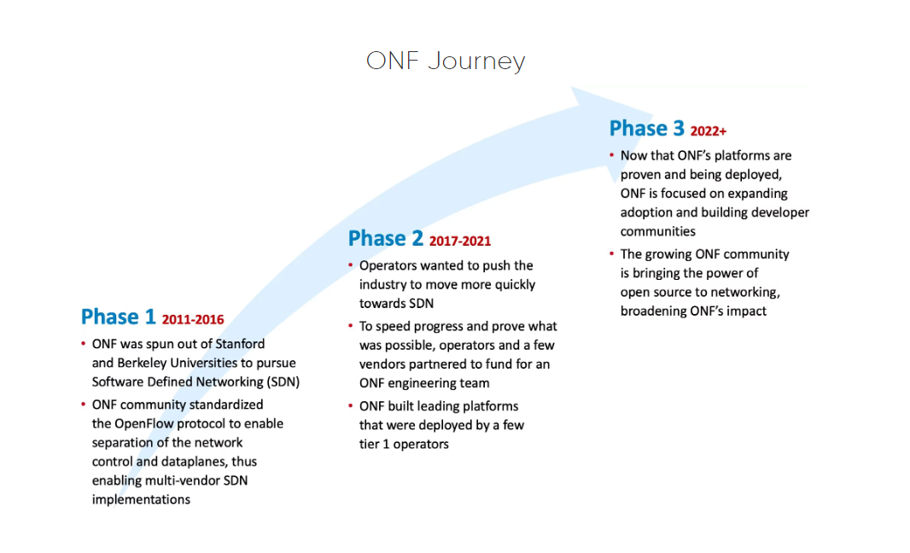

Figure 1 gui

### ODL

### Ryu

## Software Switches

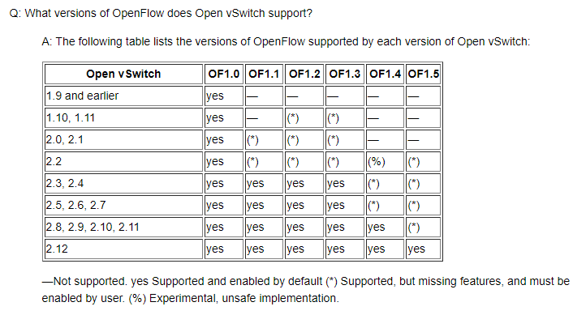

## Virtual Emulated Environment

### Mininet

Mininet is a tool specially designed for software defined networks. It is an emulator of a network and it is used to visualize and test the OpenFlow switches and application of software-defined networks in a virtualized environment. Mininet provides the space to develop and test software-defined network applications without the need to set up a physical environment. It gives a network testbed thereby allowing to develop and test applications that are using OpenFlow protocols. It also gives the flexibility to integrate python API, thereby paving the way for creating and experimenting with networks. It also has a CLI which is aware of topology and OpenFlow thereby allowing to debug or run network tests for applications. Mininet is majorly used as a learning tool to test, experiment, and learn about software-defined networks and it is preferable because it is very fast and helps to create customizable topologies.

Advantages of Mininet :

* It is very fast and takes very little time for booting.
* It is easy to install and use.
* It saves money because the emulators are cost-effective instead of testing with hardware devices.
* It is also very easy to connect with other network devices.
* It has high availability.

### GNS3

GNS3 (Graphical Network Simulation 3) is an open source, free network software emulator , which emulates and interconnects networking devices, including routers, switches, firewalls, and other devices which are interconnectable within OSI model. GNS3 is used to configure, test and troubleshoot virtual and real networks. Latest version (Version 2.2.33.1) of GNS3 support devices from multiple network vendors such as Cisco virtual switches, Cisco SD-WAN components, Open vSwitch, Brocade vRouters, Cumulus Linux switches, Docker instances, Juniper vRR, HPE VSRs, Nokia vSIM, multiple Linux appliances and many others. Furthermore, GNS3 offers no limitation on the number of devices supported or complexity of network topologies. The only possible limitations are in the CPU and memory of the hardware that runs it.

GNS3 emulates the hardware of a device and runs real images in the virtual device, so it can be used to design complex networks and do simulations about them. Since it runs real images, it is necessary to have the images of the devices to be simulated. GNS3 offers on his official website different appliances that have and already configured image and can be used to emulate a device.

GNS3 consists of two software components:

* Client part: The GNS3-all-in-one software (GUI)
* Server part: The GNS3 virtual machine (GNS3 VM)

The GNS3-all-in-one is the graphical user interface (GUI) where the topologies can be created. When the topologies are created, the devices are hosted and run by a server process. The options for the server part are the following:

* Local GNS3 server: run on the same PC where the GUI is installed.
* Local GNS3 VM: run on the same PC using virtualization software such as VirtualBox or VMware.
* Remote GNS3 VM: run remotely using VMware ESXi or in the cloud.

For this Thesis VirtualBox was preferred to host the devices on the GNS3 VM.

Advantages of GNS3:

* Free and Open Source software
* No monthly or yearly license fees
* No limitation on number of devices (only limitation is the user hardware: CPU and memory)
* Supports multiple switching options (Open vSwitch, Cumulus Linux Switches, IOU/IOL Layer 2 images, VIRL IOSvL2):
* Supports all VIRL images (IOSv, IOSvL2, IOS-XRv, CSR1000v, NX-OSv, ASAv)
* Supports multi-vendor environments
* Can be run with or without hypervisors
* Supports both free and commercial hypervisors (VirtualBox, Hyper V, VMware workstation, ESXi, Fusion)
* Downloadable, free, pre-configured and optimized appliances available to simplify deployment
* Native support for Linux without the need for need for additional virtualization software
* Software from multiple vendors freely available
* Large and active community (800,000+ members)

Disadvantages:

* Cisco as well as other software images need to be supplied by user (download from Cisco.com, or purchase VIRL license, or copy from physical device).
* Not a self-contained package, but requires a local installation of software (GUI).
* GNS3 can be affected by PC’s setup and limitations because of local installation (firewall and security settings, company laptop policies etc.).

## OpenFlow Protocol

In more specific terms, and according to the original version 1.0.0 of the standard defined in [26], an OpenFlow-enabled Switch consists of a flow table and an OpenFlow secure channel to an external OpenFlow controller. Typically, the forwarding table maintains a list of flow entries; Each flow entry comprises match fields containing header values to match packets against, counters to update when packets match for flow statistics collection purposes, and a set of actions to apply to matching packets. Accordingly, all incoming packets processed by the switch are compared against the flow table where flow entries match packets based on a priority order specified by the controller. In case a matching entry is found, the flow counter is incremented and the actions associated with the specific flow entry are performed on the incoming packet belonging to that flow. According to the OpenFlow specification [26], these actions may include forwarding a packet out on a specific port, dropping the packet, removing or updating packet headers, etc. If no match is found in the flow table, then the unmatched packet is encapsulated and sent over the secure channel to the controller which decides on the way it should be processed. Among other possible actions, the controller may define a new flow for that packet by inserting new flow table entries. Despite the advantages linked to the flexibility and innovation brought to network management, OpenFlow [24] suffers from scalability and performance issues that stem mainly from pushing all network intelligence and control logic to the centralized OpenFlow controller, thus restricting the task of OpenFlow switches to a dumb execution of forwarding actions. To circumvent these limitations, several approaches [27, 28, 29, 30] suggest revisiting the delegation of control between the controller and switches and introducing new SDN switch Southbound interfaces. Notably, DevoFlow [28] claims to minimize switch-tocontroller interactions by introducing new control mechanisms inside switches. That way, switches can make local control decisions when handling frequent events, without involving controllers whose primary tasks will be limited to keeping centralized control over far fewer significant events that require network-wide visibility. Despite introducing innovative ideas, the DevoFlow alternative has been mainly criticized for imposing major modifications to switch designs [31]. On the other hand, stateful approaches [29, 32, 33], as opposed to the original stateless OpenFlow abstraction, motivate the need to delegate some stateful control functions back to switches in order to offload the SDN controller. These approaches face the challenging dilemma of programming stateful devices (evolving the data plane) while retaining the simplicity, generality and vendor-agnostic features offered by the OpenFlow abstraction. In particular, the OpenState proposal [29] is a stateful platform-independent data plane extension of the current OpenFlow match/action abstraction supporting a finite-state machine (FSM) programming model called Mealy Machine in addition to the flow programming model adopted by OpenFlow. That model is implemented inside the OpenFlow switches using additional state tables in order to reduce the reliance on remote controllers for applications involving local states like MAC learning operations and port-knocking on a firewall.

Despite having the advantage of building on the adaptation activity of the OpenFlow standard and leveraging its evolution using the (stateful) extensions provided by recent versions (version 1.3 and 1.4), OpenState faces important challenges regarding the implementation of a stateful extension for programming the forwarding behaviour inside switches while following an OpenFlow-like implementation approach. The feasibility of the hardware implementation of OpenState has been addressed in [34]. Finally, the same authors extended their work into a more general and expressive abstraction of OpenState called OPP [35] which supports a full extended finite-state machine (XFSM) model, thereby enabling a broader range of applications and complex stateful flow processing operations. In the same spirit, the approach presented in [36] explored delegating some parts of the controller functions involving packet generation tasks to OpenFlow switches in order to address both switch and controller scalability issues. The InSP API was introduced as a generic API that extends OpenFlow to allow for the programming of autonomous packet generation operations inside the switches such as ARP and ICMP handling. The proposed OpenFlow-like abstractions include an InSP Instruction for specifying the actions that the switch should apply to a packet being generated after a triggering event and a Packet Template Table (PTE) for storing the content of any packet generated by the switch. According to [36], the InSP function, like any particular offloading function, faces the challenging issue of finding the relevant positioning with respect to the broad design space for delegation of control to SDN switches. In their opinion, a good approach to conceiving (eventually standardizing) a particular offloading function should involve a programming abstraction that achieves a fair compromise between viability and flexibility, far from extreme solutions that simply turn on well-known legacy protocol functions (e.g. MAC learning) or push a piece of code inside the switches [37, 38]. The authors of FOCUS [39] express the same challenges but, unlike the above proposals, they reject a performance based design choice that requires adding new hardware primitives to OpenFlow switches in the development of the delegated control function. Instead, they promote a deployable software-based solution to be implemented in the switch’s software stack to achieve a balanced trade-off between the flexibility and cost of the control function delegation process.

OpenFlow is normalized by the Open Networking Foundation (ONF) [5], backed by the leaders of IT industry like Facebook, Cisco, Google, HP, and others. For this reason, understanding the OpenFlow architecture is important to grasp the notion of SDN, which we are going to present in the next subsection. Before that, we should realize that OpenFlow is just an instantiation of SDN, as there are many existing and under development southbound APIs, for instance, OpFlex [6],which distributes some of the complexity of managing the network to the infrastructure layer to improve the scalability. On the other hand, ForCES [7] proposes a flexible method to ameliorate the management of traditional networks without using a logically centralized controller, while ROFL [8],which relies on OpenFlow, provides an API for software developers to enable full development of new applications [1]. [2]

# Requirements Analysis

Due to advances in the Information and Communication Technology, the configuration and management of the network components becomes highly complex and time-consuming. A fundamental characteristic of SDN is the logically centralized, but physically distributed controller component. SDN offers to batch-configure automatically multiple components in one step, while the traditional way would mean to log into each device. Many operators struggle with the migration from IPv4 to IPv6, SDN with its centralized control and the possibility to reduce human error due to increased poses an opportunity to help make this migration easier. The controller maintains a global network view of the underlying forwarding infrastructure and programs the forwarding entries based on the policies defined by network services running on top of it. The traditional networking approach has very limited facilities to explore these aspects of networking and the goal would be to study these futuristic characteristics of networking.

## General Objectives

The detailed requirements for this thesis and the involved tasks are stated below:

* Build a suitable network with different network devices in the emulation software.
* Manage different services and network configurations with SDN controller in an emulated environment.
* Create and distribute the network configurations for network devices.
* Develop a rationale and setup an IPv4 and IPv6 scheme for the network.
* Provide services and user groups that have different requirements.
* Evaluate advantages and disadvantages of network with SDN controller over traditional network.
* Proof and validation of functioning failover mechanisms to improve resilience.

Throughout this thesis, the following research questions are answered:

* Research possible open-source SDN controllers to implement.
* Research alternative configuration methods with the goal of finding the best possible method to configure and manage the network through Network Controller.
* How to provide different paths in the network with different QoS properties?
* Algorithms that are responsible for the optimization of the paths.
* When a service is accessible at multiple times, how to choose the best one.

## Work Plan

Work flow for this Thesis is as follows;

* Research about the SDN controllers.
* Research about the emulation software.
* Installation and testing of different SDN controllers.
* Configuration of these SDN controllers.
* Installing and activating the features required for the services and applications running on the SDN controller.
* Installing different network devices preferably open-source devices to run inside the emulated environment.
* Setting up the connection between these networking devices and the SDN controller.
* Document the difficulties and errors found while installation and debugging the connectivity between the different network devices and SDN controller
* Creating and implementing different network topologies.
* Creating use cases suitable for SDN controller in the emulated environment.
* Implementing and testing these use cases in the emulated environment.

## Previous Work

Through the study and research about implementation of SDN controllers in virtual environments, the following points were found;

* Currently various Open-source SDN controllers are available to be implemented and tested in the environment. To name few, OpenDayLight (ODL), Open Network Operating System (ONOS), Ryu and Faucet.
* ONOS and ODL are built to have centralized architectures. Hence, they tend to be easier to maintain and confer lower latency between the tightly coupled southbound APIs and northbound APIs.
* Faucet is built to have distributed architectures which generally are more complex to maintain and deploy but can allow the platform to scale more effectively. By decoupling the processing of PCE, Telemetry and Southbound interface traffic, each function can be scaled independently to avoid performance bottlenecks.
* Whereas, Ryu is different to the other options, although having a core set of programs that are run as a platform, it is better thought of as a toolbox, with which SDN controller functionality can be built.
* ONOS and ODL are written in Java, for which development resources are abundant in the market, with good supporting documentation and libraries available.
* Ryu and Faucet are written in Python, a well-supported language and has an active community developing the framework. The documentation is concise and technical, aimed at developers to maximize the utility of the system.
* Both ODL and ONOS benefit from large developer and user communities under the Linux Foundation Networking banner. Many large international players are involved in the development and governance of these projects, which could add to the longevity and security over time.
* Ryu and Faucet are well supported, targeted controllers. Due to the emerging nature of the field, both options look to have a bright future, with a simpler, streamlined approach to change submission and testing.
* Most of the software defined networking testbeds are implemented and analysed with the Mininet environment.
* Mininet being network emulator is used to deploy quick network topologies with Open vSwitch supporting SDN protocols along with in-built SDN controller. These are ran as virtual instances inside the Mininet environment.
* In GNS3, real images of the network devices are used which are almost identical to the real world network devices. Quite few experimental research was found where SDN controller was tested with network topologies created using the network devices in GNS3 environment.
* New versions of OpenDayLight controller do not support the GUI (DLUX application features) and L2 switch applications. Study reveals the projects associated with these applications were separated from OpenDayLight.

# Realization

After researching about various SDN controllers, few suitable SDN controllers were selected for building a virtual environment on the emulation software. These SDN controllers were Open Network Operating System (ONOS), OpenDayLight (ODL) and Ryu. Similarly, to create the network with network elements, two emulation software were selected, namely, Mininet and GNS3.

## Installation of testbed

For setting up the testbed for this Thesis work, all the major components were installed on the Oracle VM VirtualBox virtualization application. Different virtual machines were created for each SDN controller.

Mininet-VM and GNS3 VM were also running on different instances of Virtual Machines. Mininet-VM is capable of creating topologies with Open vSwitches, hosts and SDN controller all in itself. When topologies are created in GNS3 using the all-in-one software GUI client, the devices created are need to be hosted and run by a server process, for this GNS3 VM instance is used. All SDN controllers have their complete installation in respective virtual machines.

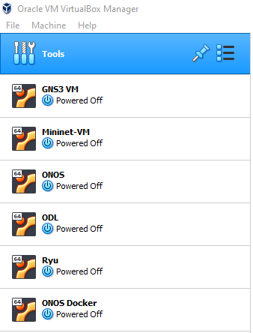

Figure 4. 1: Different virtual machines instances in VirtualBox

Topologies created inside the GNS3 and Mininet are able to connect to the outside SDN controller using OpenFlow protocol. SDN controllers are running as a service, meaning after installation the controllers VMs were configured to directly run them as SDN controller without need of any separate command to start the controller. All these SDN controllers and emulation software were set up using standard scripts and no special optimization was performed.

For experimenting the use cases with these SDN controllers few different virtual machines were created with the complete experiment setup. For example, in use case for testing the network with multiple controllers, running the multiple controllers in separate machine would require the large amount of resources. And for this reason multiple controllers were installed as Docker containers and separate virtual machine named *ONOS Docker* was created for this use case.

For the tasks associated with this master thesis, following is the list of software and machine configuration utilized.

|  |  |  |
| --- | --- | --- |
| **Category** | **Software** | **Version** |
| Host Machine Operating system | Windows 10 Home | 21H2 OS build 22000.856 |
| Host Machine Processor | Intel(R) Core(TM) i7-1065G7 8 CPUs @ 1.30GHz 1.50 GHz |  |
| Host Machine RAM | 16.0 GB |  |
| Host Machine Graphics | Intel(R) Iris(R) Plus |  |
| Software Device | Open vSwitch | 2.12.3 |
| GNS 3 - Client part | GNS3-all-in-one software | 2.2.33.1 |
| Traffic Analyzer | Wireshark | 3.6.6 |
| Virtual Machines Hypervisor Manager | Oracle Virtual Box | 6.1.36 r152435 (Qt5.6.2) |
| 1. GNS3 VM |  |  |
| * 1. GNS3 VM | Server | 2.2.33.1 |
| * 1. GNS3 VM Operating System | Ubuntu | 20.04 Desktop |
| * 1. GNS3 VM RAM, Memory, CPUs | 8.0 GB, 40 GB, 3 |  |
| 1. Mininet-VM |  |  |
| * 1. Mininet |  | 2.3.0 |
| * 1. Mininet-VM Operating System | Ubuntu | 20.04 Desktop |
| * 1. Mininet-VM RAM, Memory, CPUs | 2.0 GB, 10 GB, 2 |  |
| 1. ONOS-VM |  |  |
| * 1. ONOS | X-Wing (LTS) | 2.7.0 |
| * 1. ONOS-VM Operating System | Ubuntu | 20.04 Desktop |
| * 1. ONOS-VM RAM, Memory, CPUs | 4.0 GB, 15 GB, 3 |  |
| 1. ODL-VM |  |  |
| * 1. ODL | Sulfur | SR1 |
| * 1. ODL-VM Operating System | Ubuntu | 20.04 Desktop |
| * 1. ODL-VM RAM, Memory, CPUs | 2.0 GB, 10GB, 33 |  |
| 1. Ryu-VM |  |  |
| * 1. Ryu |  | 4.34 |
| * 1. Ryu-VM Operating System | Ubuntu | 20.04 Desktop |
| * 1. Ryu-VM RAM, Memory, CPUs | 2.0 GB, 10 GB, 23 |  |
| 1. ONOS Docker-VM |  |  |
| * 1. ONOS | Peacock (LTS) | 1.15.0 |
| * 1. ONOS Docker-VM Operating System | Ubuntu | 20.04 Desktop |
| * 1. ONOS Docker-VM RAM, Memory, CPUs | 3.0 GB, 20 GB, 2 |  |

## Implementation with GNS3

After complete installation and necessary configuration of the components required for this Thesis work, a topology with four Open vSwitches and three routers was created in the GNS3 application. For testing the reliability of network, the routers are deployed at same node and far end nodes of the topology.

In GNS 3, to connect any network device to the Internet or SDN controller, which is installed and running outside the GNS 3 software, a NAT interface is used. A L2 switch (Switch1 in Figure 4.2) is used so that all devices can be directly connected to the NAT interface with just single interface. SDN controller used here is ONOS controller.



*Figure 4.2: Topology created in the GNS3 with different Network devices*

The eth0 interface of Open vSwitch is the management interface which is used for communication with SDN controller and therefore, the eth0 interface needs to have an IP address. Here eth0 interface is configured to have an IP address from the DHCP pool of the GNS 3 Server VM. Before booting up the Open vSwitches, the configuration file needs to edited to request the address from the DHCP pool.



Once the Open vSwitch is booted up and ready to establish connection with the SDN controller, it needs to be confirmed that all the other interfaces of the Open vSwitch are configured under the same Bridge interface. Ideally all the other interfaces of the Open vSwitch are configured under the Bridge *br0* interface, if not, these needs to be manually configured.



*Figure 4.3: Commands and confirmation*

Bridge br0 is the logical management interface on the Open vSwitch which accepts the configuration commands from the SDN controller. To connect this interface to the SDN controller, external IP address of the SDN controller (here, 192.168.0.114) and port number on which SDN controller is listening to OpenFlow protocol needs to be specified (here, 6653).

Before connecting the Open vSwitches to the SDN controller, OpenFlow protocol version (here OpenFlow protocol version 1.4) also needs to be specified along with the bridge interface being used.



*Figure 4.3: Commands and confirmation of Open vSwitch connection to the ONOS controller*

As seen in Figure 4.3, interface Br0 was connected to the controller at the given IP address and the Boolean value is set to **True**. To confirm the connection from the controller side, two options can be utilized first, *ONOS CLI* and other *ONOS GUI*.

The ONOS CLI is an extension of Karaf's CLI. As a result, it is capable of leveraging features such as programmatic extensibility, the ability to load and unload bundles and SSH access. To access the ONOS CLI from the local machine itself, following command is used.



To access the ONOS CLI from the host or remote machine, SSH keys need to be shared between the machines. The ONOS CLI listens on port number 8101. To access the ONOS CLI from the remote machine, following login credentials are used.



Or to access the Karaf’s CLI, following login credentials are used.





*Figure 4.4: List of devices (Open vSwitch) connected to the ONOS controller*

On the ONOS CLI, ***devices*** command is used to list out the information about the connected devices ( i.e. Open vSwitches) to the ONOS controller. The list presents the detailed information of the devices like ID or label of the device, Availability of the device, role of the ONOS controller for that device, protocol used at the Southbound interface, etc. In the above figure it is observed that four devices are connected to the ONOS controller using the OpenFlow protocol version 1.4.

Alternatively, ONOS GUI can be also be used to confirm the connection from the controller side. The *onos-web-gui* feature application must be installed and activated on the ONOS. On the browser, the ONOS GUI listens on port number 8181. The base URL is /onos/ui; for example, to access the GUI on localhost, use: <http://localhost:8181/onos/ui> or <http://192.168.0.114:8181/onos/ui>. The default username and password for accessing the ONOS GUI are ***onos*** and ***rocks*** respectively.



*Figure 4.5: Topology view on the ONOS GUI*

A Wireshark was ran between the ONOS controller and one of the Open vSwitch to realize the packets transferred between them. Southbound protocol OpenFlow was also captured in this link and figure 4.6 shows the Wireshark capture of the same. In the following Wireshark snippet, one can observe the initial OpenFlow packets exchanged between the Open vSwitch and ONOS controller for connection establishment.



*Figure 4.6: OpenFlow protocol packets captured on the Wireshark*

Figure 4.7 is the Wireshark packet snippet of OpenFlow Hello packet send from Open vSwitch to the ONOS Controller for establishing the connection. In the following packet, one can confirm the OpenFlow protocol version 1.4 being used for communication between the ONOS controller and Open vSwitches.



*Figure 4.7: OpenFlow protocol Hello packet captured on the Wireshark*

### ONOS GUI

The ONOS GUI is a single-page web-application, providing a visual interface to the ONOS controller. ONOS GUI provides a great and easy to understand information about the ONOS controller and the topology connected to with it. Information such as applications installed on controller, number of devices connected, number of hosts, port numbers used in the topology, number of packets transferred between the links, and many more information is easily accessible through ONOS GUI. Following two features are required to be installed and activated on the ONOS for accessing the ONOS GUI.



ONOS GUI listens on port number 8181. The base URL is /onos/ui; for example, to access the GUI on localhost, use: <http://localhost:8181/onos/ui> or <http://192.168.0.114:8181/onos/ui>. The default username and password for accessing the ONOS GUI are ***onos*** and ***rocks*** respectively.



The ONOS Cluster Node Panel indicates the cluster members (controller instances) in the cluster. The Summary Panel gives a brief summary of properties of the network topology. The Topology Toolbar offers push-button / toggle-button actions that interact with the topology view. The Navigation Menu button provides access points to the various components of the network, from where one can view and configure various aspects of the network element.



|  |  |
| --- | --- |
| **View** | **Description** |
| **Platform Category** |  |
| Applications | The Application view provides a listing of applications installed, as well as interaction with them on the network. |
| Settings | The Settings view provides information about all configurable settings in the system. |
| Cluster Nodes | The Cluster Nodes view provides a top level listing of all the cluster nodes, (ONOS instances), in the network. |
| Packet Processors | The Packet Processors view shows the currently configured components that participate in the processing of packets sent to the controller. |
| Partitions | The Partitions view shows information about how the cluster partitions are configured. |
| **Network Category** |  |
| Topology | The Topology view provides an interactive visualization of the network topology, including an indication of which devices (switches) are mastered by each ONOS controller instance. |
| Devices | The Device view provides a top level listing of the devices in the network. |
| Flows | The Flow view provides a top level listing of all flows for a selected device. (Note that this view would be able to access under the Device view.) |
| Ports | The Port view provides a top level listing of all ports for a selected device. (Note that this view would be able to access under the Device view.) |
| Groups | The Group view provides a top level listing of all groups for a selected device. (Note that this view would be able to access under the Device view.) |
| Meters | The Meter view provides a top level listing of all meters for a selected device. (Note that this view would be able to access under the Device view.) |
| Links | The Link view provides a top level listing of all the links in the network. |
| Hosts | The Host view provides a top level listing of all the hosts in the network. |
| Intents | The Intent view provides a top level listing of all the intents in the network. |

The Application view of installed and activated applications on the ONOS controller describing the name, the APP ID, version, category of the application and the developer of that application. The top right corner buttons on the Application view provides the one click installation/ uninstallation, activate/ deactivate, upload and download .OAR file of the selected application.

Following is the Application view of some of the applications used during this Thesis work.



The Device view provides the information about the devices connected to the ONOS controller. It provides the detailed information like Device ID (mostly the MAC address of the device interface connecting to the ONOS controller), Master ONOS controller of that device, Number of ports of that device, vendor, hardware and software version of the device and southbound interface protocol with its version used for communication.

Upon selecting a specific device, the top right corner buttons on the Device view provides more information such as Flows, Ports, Meters and Groups of the device. The following figure shows the list of four devices connected to single Master ONOS controller using OpenFlow protocol version 1.4.



Upon selecting a specific device from the Device view and choosing the Port view of that device, one can monitor the traffic flowing through the different ports of that device. Different measurement formats are available on the Port view along with the duration of that port being active.

The following figure provides the information about the ports of one of the device (Open vSwitch-1) connected in the network. Note that the total number of ports mentioned here is 15 whereas in the previous figure (Device view) total number of ports is 16. This is because Port 0 (interface eth0) is management interface whose sole purpose is to accept the configuration from the ONOS controller, therefore this eth0 interface is not displayed in this list of ports. The interface eth1, eth2 and eth3 of the Open vSwitch-1 are being connected to other network elements in the network and hence the traffic flowing through this interfaces is observed in the following figure.



The Link view displays the list of total Links in the network. These links are only between two devices and not between the host and the device. The following figure presents the list of three links present between the four devices in the network. The exact port (Device ID/ Port) of the device and type of the link can be observed in the figure.



The Host view displays the list of total Hosts connected in the network. The detailed information of the hosts such as Host ID (MAC address of the host), VLAN ID if host is part of any VLAN, IP address and on which port of the device the host is connected in the network. The following figure displays the list of three hosts connected in the network with their respective IP addresses.



The following figure displays the Quick help and keyboard shortcuts used on the ONOS GUI.



### Creation and Installation of Flows

The OpenFlow operating instructions transmitted from the SDN Controller to the Open vSwitch are structured as ***Flows***. Each individual flow consists of flow priority, packet processing instructions, packet match fields, counters, and flow timeouts. The Flow Tables are used to organize the flows. An incoming packet on the switchport may be processed by multiple flow tables before exiting from egress switchport.

Upon the occurrence of some events, the SDN controller reactively or proactively updates the flow table. In a reactive approach, the controller does not populate the flow table with any rules at the beginning of the network operation. Whenever packets reach switches during network operation, the controller will install rules into the flow table. When network operation starts, the controller will install flow entries in the flow table in advance as part of the proactive strategy. The proactive approach was introduced to minimize the communication overhead involved between controllers and network devices. In order to maximize network performance, especially in large networks like data centres, choosing the correct flow rules is essential. The flow of an arriving packet is compared to flow entries (packet match fields) in the flow table as it arrives at a switchport during traffic flow. If matching is missing in the flow table, the switch will communicate with the controller to update the flow table with entries that will let the packet get to its destination. Thus, a delay is created before the packet can be transmitted to the next hop as it involves the communication overhead between the SDN Controller and Open vSwitch.

The OpenFlow pipeline contains multiple flow tables and each flow table contains multiple flow entries. [3] The flow tables are numbered starting from 0 and a flow table can have a maximum of 65535 flow entries in Open vSwitch. The OpenFlow pipeline processing begins from Flow Table 0 where the packet match fields are checked. The outcome of the first flow table decides the packet processing by other flow tables. There must be at least one Flow Table in the Open vSwitch. A flow table entry is decided by the match fields and priority value. The packet match fields are extracted from the packet type are mostly packet headers like Source and Destination IP and MAC address. Also Ingress ports and the metadata fields can be used for packet match fields. The metadata field can be used to transfer the information to the other flow tables within the Open vSwitch.



When the packet arrives at the ingress port of the Open vSwitch, it is checked for flow table match fields. When the match fields are satisfied with the table entry requirement, the packet is processed by the flow table. Inside the flow table the packet is matched with the flow entries and the instruction set included in that flow entry is executed. The instruction might also include the packet to be processed by another flow table and if the instruction set does not include packet forwarding to the next flow table, packet pipeline processing stops. When packet pipeline processing stops, the packet is processed with its associated action set.

An action set is connected with each packet. This set is empty at the beginning of packet processing. An action set contains a maximum of one action of each type. A flow table can modify the action set with the help of instructions linked with a particular match. [3]

If Open vSwitch contains just a single flow table, a flow table match field value is set to ANY so that it matches all possible values in the packet header. If a packet does not satisfy any match fields, flow entry in the flow table can specify how to process unmatched packet. For example, the packet can be dropped or send the packet to the controller for processing.

The ONOS controller and Open vSwitch together provide three options to install flows on the Open vSwitch. First option through the REST API on the ONOS controller, second option through the commands on ONOS CLI and third option through the commands on Open vSwitch CLI. By default the flow table 0 is created in the Open vSwitch with few flows directing different type of traffic towards the ONOS controller for processing. Following figure shows the installed flow table 0 on the Open vSwitch CLI before configuring any flow rules. The command ***ovs-ofctl -O OpenFlow14 dump-flows br0***is used to display all the flows installed on the Open vSwitch. In this command OpenFlow protocol version (*OpenFlow14*) used for traffic transmission needs to be specified along with the logical management interface (*br0*) of the Open vSwitch. The following figure displays the output of this command on the Open vSwitch-1 in the created test network.



As seen in the above figure, seven flows are already installed on the Open vSwitch before configuring any flows manually. These flows are by default installed by Open vSwitch after getting connected to ONOS controller for smooth transmission of traffic in the network. Note that all flows are directing traffic towards the ONOS controller *(actions=CONTROLLER:65535)* for processing of the received packet. CONTROLLER:65535 means that the switch should send only the first 65535 bytes of the packet to the controller. All the flows are installed under the flow table 0 and action set value is set to clear.

These basic flows are installed to circulate the traffic of basic packet types. These packets contains the header field of Address Resolution Protocol (ARP), IPv4 or IPv6 addresses, Multicast addresses (*nw_dst=224.0.0.0/4*), Link Layer Discovery Protocol (LLDP) (*dl_type=0x88cc*) and Open Network OS (*dl_type=0x8942*).

The following figure displays the same default flow rules from the ONOS CLI.



To install the flow manually from the Open vSwitch CLI, *ovs-ofctl add-flow* command is used. Along with these command few other parameters are required to be passed to install the flows successfully. These must have parameters are flow table number, priority value, packet match fields, action set. The following figure displays the installation of two flow rules, which were installed through the Open vSwitch CLI.



The flows were installed to transmit the traffic between the Router R1 (mac address: ca:01:0f:ae:00:08) and Router R3 (mac address: ca:03:17:6d:00:08) in the created test network. The following set of commands were used to install the flows on Open vSwitch-1.

*ovs-ofctl add-flow br0 "table=0, priority=100, in_port=eth1, dl_src=ca:01:0f:ae:00:08, dl_dst=ca:03:17:6d:00:08, actions=output:eth3"*

*ovs-ofctl add-flow br0 "table=0, priority=100, in_port=eth3, dl_src=ca:03:17:6d:00:08, dl_dst=ca:01:0f:ae:00:08, actions=output:eth1"*

Two flows were installed on the Open vSwitch-1 to transmit and receive the traffic between the routers R1 and R3. Along with add-flow command, some parameters are described to get the desired output. These parameters are as such seen in the above set of commands: flow table number (*table=0)*, priority value (*priority=100)*, packet match fields (*in_port=eth1, dl_src=ca:01:0f:ae:00:08, dl_dst=ca:03:17:6d:00:08,*), action set (*actions=output:eth3)*.

In these flow rules, packet match fields have three conditions to satisfy: input port, source mac address and destination mac address. Upon arrival of any packet at switchport eth1 of Open vSwitch-1, the packet is checked for these packet match fields. When these all three conditions are matched, appropriate performance is carried out as mentioned in the action set, i.e. to forward the packet from switchport eth3 of Open vSwitch-1. Thus, the Open vSwitch will forward the matched packet from eth3 without communicating with the ONOS controller. If any of the match field was not satisfied with the match condition, the packet would be forwarded to the ONOS controller for further processing.

Another method to add flows is through REST API on the ONOS controller. In this method the flow configuration file in JSON format is created. The following figure shows the snippet of one such flow configuration *flows.json* file.



The flow was created to transmit the traffic between the Router R2 (mac address: ca:02:0f:be:00:08) and Router R3 (mac address: ca:03:17:6d:00:08) in the created test network.

The selector criteria field basically sets the packet match field values. As seen in the above figure, these values were set to match the Input port, source and destination MAC address and source and destination IP address. The treatment field contains the instructions when the packet match field values are matched. Herein the instruction is set to forward the packet from the interface eth3 of the Open vSwitch-1.

If the ONOS controller is downloaded and installed as a package, flows.json file needs to be transferred to the server using the cURL specifying the location of file on local machine as shown below.

*curl -X POST -H "content-type:application/json" http://192.168.0.114:8181/onos/v1/flows -d @/opt/onos/config/flows.json --user onos:rocks*

The successful installation of this flow rule can be observed on the Open vSwitch-1 CLI as seen in the following figure.



For test purposes, the flows can be added with the following command used from the ONOS CLI. Temporary flows are installed for the testing purpose and these flows are cleared after the test is complete. The flows per device and number of iterations arguments are required to be set with the *add-test-flows* command.



The successful testing of the flows can be seen in the following figure. In this test scenario, two flows were created on each device and three such iterations were performed. The following snippet shows the test run to be successful and the time taken by each iteration can be observed adjacent to the Run number.



Along with all these different flow creation and installation methods, ONOS controller has been built to provide the great overview of possible functions related to the flows management through the RESTful API. On this RESTful API, REST methods such as GET, POST and DELETE can be found to manage the flows on the Open vSwitches. This RESTful API document can be found at the easy to access link, [*http://192.168.0.114:8181/onos/v1/docs/#/flows*](http://192.168.0.114:8181/onos/v1/docs/#/flows)

This REST API contains the different features related to the ONOS controller components management. Each of these features comprises of multiple REST methods to GET overview of that component, POST new instructions for that component or DELETE some rules from that component. Each of these REST method contains the different arguments such as implementation notes, parameters, response messages, curl, request URL, response code, response headers, etc.

The following figure shows the REST methods offered at ONOS RESTful API for managing the *Flows* component of the ONOS controller.



These are the different possibilities offered by ONOS controller and Open vSwitch for creation, installation and management of the *flow rules*. Another such significant ONOS component is *Intents.*

### Creation and Installation of Intents

ONOS controller consists of subsystem named *Intent subsystem.* ONOS refers to the collection of components as a subsystem or sometimes as a service. This Intent subsystem works on the Intent Framework. The Intent Framework is a subsystem that allows applications to specify their network control desires in the form of policy and these policy-based directives are *Intents*. An Intent is a model object that defines an application's request to modify the network’s functioning to the ONOS core. The ONOS core receives the intent specifications and translates them with the help of intent compilation, into installable intents, which are primarily actionable operations on the network environment. These actions are executed by intent installation process, which eventually make some changes in the network environment, such as flow rules being installed on the switches, tunnel links being provisioned and many more.

When an intent is delivered by an application, it is send into the compiling phase. Upon successful compiling, an intent would be forwarded to the installing phase or in case of unsuccessful compilation, it would be send to failed state. After successful installation of an Intent, it is finally passed to the installed state or in event of installation failure, an intent is send to the recompile state. An intent might be withdrawn if an application decides that it no longer requires the intent.

An Intent should consists of Intent ID, Application ID, Intent key, Priority value and Network resources. An Intent might also contain other attributes such as Ingress port, Egress port, Encapsulation type, etc depending on Intent types. ONOS supports various types of Intent installation. Following are some of the types of Intents.

1. Host to host intents
2. Point to point intents
3. Single point to multi point intents
4. Multi point to single point intents
5. Flow rule intents
6. Flow objective intents

ONOS controller consists of three different techniques for creation of intents in the network environment. First technique is through the commands on ONOS CLI, second technique is through the ONOS GUI and the third technique is through the REST API on the ONOS controller.

The following figure displays the syntax for creating the host-to-host intent from the ONOS CLI. All other types of intents can also be created from the ONOS CLI, with few alterations to the displayed syntax.



The use of *add-host-intent* command on the ONOS CLI creates the host-to-host intent between the two hosts whose hosts IDs are provided in the command. Other optional attributes such as Intent key, priority value, ethernet type, source and destination MAC addresses, bandwidth, etc can also be passed along with the intent creation command. The following figure shows the use of this command.



A host-to-host intent was created between the Router R1 (mac address: ca:01:0f:ae:00:08) and Router R3 (mac address: ca:03:17:6d:00:08) in the created test network. The above figure shows the intent was submitted for compilation and further installation, if all the provided attributes are valid. If the other necessary attributes required for installation of intent are not declared in the command, those are created by ONOS itself. The following figure shows the successful installation of the host-to-host intent.



Another method to create the intents in the network environment is through the ONOS GUI. The ONOS controller provides the easy to create and install the intents between the network elements. To create an intent from the ONOS GUI, simply press the Shift key on keyboard and select the desired devices displayed on the Topology view. A dialogue box named Selected Items will pop up on the right side of the screen displaying the host IDs of the selected hosts. At the bottom of this dialogue box two buttons are present, one to create flow and other to show related traffic. After selecting the desired hosts, click on the create flow button to create the intent and then show related traffic button to display the related traffic flowing between the Open vSwitches. The following figure shows the creation of one such intent.



MultiPoint-to-SinglePoint intent was created between the three routers Router R1 (MAC address: ca:01:0f:ae:00:08, IP address: 10.0.0.1), Router R2 (MAC address: ca:02:0f:be:00:08, IP address: 10.0.0.2) and Router R3 (MAC address: ca:03:17:6d:00:08, IP address: 10.0.0.3) in the created network. The following figure shows the successful installation of MultiPoint-to-SinglePoint intent.



If MultiPoint-to-SinglePoint intent is installed from the ONOS CLI, ingress ports of the switch and egress port of the switch are required to be provided rather than the host IDs.

Another method to create the intents is through REST API on the ONOS controller. In this method the intent configuration file in JSON format is created. The following figure shows the snippet of one such intent configuration intents.json file.



A host-to-host intent was created between the Router R2 (mac address: ca:02:0f:be:00:08) and Router R3 (mac address: ca:03:17:6d:00:08) in the created test network. The priority of 1000 will be basically set as the priority value of flow rule developed for this intent. Since this is host-to-host intent, parameter *one* acquires the host ID of first host and parameter *two* acquires the host ID of the desired second host. If the ONOS controller is downloaded and installed as a package, intents.json file needs to be transferred to the server using the cURL specifying the location of file on local machine as shown below.

*curl -X POST -H "content-type:application/json" http://192.168.0.114:8181/onos/v1/intents -d @/opt/onos/config/intents.json --user onos:rocks*

The successful installation of this intent can be observed through the ONOS CLI as seen in the following figure.



Along with all these different intent creation and installation methods, ONOS controller has been developed to provide the great overview of possible functions related to the intents management through the RESTful API similar to the flows management. On this RESTful API, REST methods such as GET, POST and DELETE can be found to manage the flows on the Open vSwitches. This RESTful API document can be found at the easy to access link, [*http://192.168.0.114:8181/onos/v1/docs/#/intents*](http://192.168.0.114:8181/onos/v1/docs/#/intents)

This REST API contains the different features related to the ONOS controller components management. Each of these features comprises of multiple REST methods to GET overview of that component, POST new instructions for that component or DELETE some rules from that component. Each of these REST method contains the different arguments such as implementation notes, parameters, response messages, curl, request URL, response code, response headers, etc.

The following figure shows the REST methods offered at ONOS RESTful API for managing the *Intents* on the ONOS controller.



These are the different techniques offered by the ONOS controller for creation, installation and management of the *Intents*. All these techniques were used to create and install the different types of instants between the network elements on the created network environment. The following figure provides the view of all these intents being installed successfully.



## Implementation with Mininet

The ONOS controller was integrated and tested with another network emulated environment, Mininet. Mininet provides easy to create virtual network consisting of software switches, hosts and controller, each of these running real kernel and application code on a single machine. It provides a simple network testbed for creating software-defined networks and developing OpenFlow applications. It also includes a CLI that is topology aware and OpenFlow aware, for debugging and analysing the complete network.

In order to create the testbed for this thesis, Mininet VM image (Mininet’s latest version 2.3.0) was downloaded and installed. This pre-packaged Mininet VM image is based on the Ubuntu 20.04 OS. This Mininet VM image includes Mininet itself, all OpenFlow binaries and tools pre-installed, and tweaks to the kernel configuration to create larger virtual networks. To login to this Mininet VM, username: *mininet* and password: *mininet* are required.

Once logged in, a normal Linux CLI is presented. By using ***sudo mn*** command, a small network of two hosts, one switch and one controller can be created. After successful creation of this network, directly a Mininet CLI is presented as seen in the following figure. Mininet’s CLI allows to control and manage entire virtual network from a single console.



Mininet is configured to install this small network by using ***sudo mn*** command, which basically is a start command for Mininet. As seen in the above figure, a virtual network of the mentioned network nodes was created successfully. A ***dump*** command on Mininet CLI provides the interface information about the created network nodes. Various other commands control and manage the network can be found with ***help*** command on the Mininet CLI.



One such command is ***iperf*** which is used for testing the TCP bandwidth between the created hosts. As seen in the above figure, results of the above command shows the high bandwidth between the created hosts.

By default, Mininet runs Open vSwitch in OpenFlow mode, which requires an OpenFlow controller. The other SDN controllers already installed in this Mininet VM are OpenFlow reference controller, Open vSwitch’s ovs-controller, NOX and Ryu. After testing all these controllers, NOX and Ryu controllers were showing few errors. Another option Mininet provides is to connect to the SDN controller running outside the Mininet VM.

The Mininet is capable of creating and booting up the virtual network at great speed. Even the large scale networks are created within few seconds of time. The following figure displays the total time taken for creating the network, adding and configuring all the network nodes, adding links between them and then destroying the network of 64 hosts, 21 switches and one controller in just 7.885 seconds.



For creating this network, the tree topology was utilized as seen in the command used. The other two arguments, *depth=3* and *fanout=4* are applied to define the structure of the tree topology. By depth of 3, Mininet understands to create network of three layers of switches or three rows and by fanout of 4, it understands to create four nodes under each network node at each layer. Hence, layer one will have 1 switch, layer two will have 4 switches, layer three will have 16 switches and layer four consists of all 64 hosts. The another argument of *--test none* was utilized thereby the Mininet understands that no tests to be executed and only to set up and tear down the requested topology.

The same network was also tested for checking the connectivity between the hosts. The ICMP ping was tested between these 64 hosts and in total 4096 pings were exchanged between them and this test was completed in 79.360 seconds.

Mininet supports creation of many different topologies and running different tests on the network. When the Mininet is instructed to create the network, by default, the switches and the controller are put in the root namespace of the machine whereas only the hosts are put in their own separate namespaces.

Nevertheless, the switches can be initiated in their own namespace, by passing the ***--innamespace*** argument while starting the Mininet. This option does provide an example of how to isolate different switches. In terms of functionality this results in, the switches will talk to the controller through a separately bridged control connection instead of using a loopback interface. This option does not support the creation of network with Open vSwitches. [4]

If the first string typed into the Mininet CLI is a controller, switch or host name, the command is executed on that network node. Only the network is virtualized, each host process sees the same set of processes and directories as that seen by the root network namespace.

The following figures display the example of executing the commands on host h1 and switch s1 from the Mininet CLI. The host h1 was created in its own namespace while switch s1 was created in machine’s namespace.





Mininet supports the creation of desired custom topologies. Custom topologies can be easily defined using a simple Python API. The syntax and example of this Python API is as shown in the following figure.



A custom topology of 15 Open vSwitches and 12 hosts was created by using this Python API and connected to the ONOS controller installed outside the Mininet VM. As seen in the following figure, the remote controller arguments needs to be passed with the controller’s IP address and location of the custom topology Python file while initiating the Mininet.



The topology was created and connected to the ONOS controller successfully. The created network was tested with the ICMP ping messages with 100% success rate.



The following figure shows the view of the created topology from the ONOS controller GUI.



ONOS controller contains a built in workflow named ***onos.py*** to integrate the ONOS controller with the Mininet emulator. [5] If Mininet has been installed on a machine, ONOS can also be installed on the same machine and both can be integrated together. With Mininet and onos.py, one can easily start up an ONOS controller and a desired virtual network can be created for any topology in a single VM.

This testbed is ideal for the developers who always search for an easy, end-to-end workflow that automatically creates a single or multiple nodes ONOS controller and a virtual Mininet network, all in a single VM running Ubuntu natively. This simplifies development setup because the entire emulated network lives in a single development and share a single Linux kernel which eventually is more efficient than multiple VMs development setup.

Additionally, onos.py creates the network in which one can easily change the number of nodes in the ONOS cluster, as well as other components like the delay or bandwidth between the nodes. This workflow provides a single, unified console via the ***mininet-onos*** where one can execute both Mininet and the ONOS commands. This workflow is also suitable to handle the port forwarding, so one can easily connect to the GUI or to the Karaf’s CLI by connecting to the correct ports on the VM.

## Problems identified

During the installation of the components used in this Thesis few challenges were faced. Similarly while implementing and testing the connectivity between the SDN controller and the network devices few problems were identified. Following are the problems encountered and possible fixes for the same;

* Installation of SDN controllers is easier when they are downloaded as a packet rather than directly installing from source code.
* Open vSwitch application available for GNS3 on GNS3 Marketplace (named, Open vSwitch with management interface) has some errors and needs to be fixed before using.
* New versions of OpenDayLight controller do not support the GUI and L2 switch applications since these projects were separated from OpenDayLight.
* On repeated use of same Open vSwitches for multiple use cases, ONOS controller confuses and configures rules from one network to another network. The reason behind this is the Open vSwitches used have the same MAC addresses in both the networks. This can be taken care by clearing all configurations and data on the ONOS controller using command ***wipe-out please*** on ONOS CLI.
* Unlike previous versions of OpenFlow protocol, latest version of this protocol needs to be explicitly configured on all the networking devices.
* Before connecting the Open vSwitch to the controller, Open vSwitch needs to be specified with the version of OpenFlow protocol to be used.
* Also, need to specify the latest version of OpenFlow protocol while executing the topology commands on Mininet.
* Some of the functioning services of SDN controllers are renamed or completely changed for better functionality of the controller and the documentation available to configure these services are associated with previous versions and hence these documentations are outdated.

## Use Case-1: Testing the ONOS Controller with Isolated L2 Overlay Networks

From time to time Internet Service Providers (ISPs) are puzzled over better VPN services to provide. Where L2VPN offer lower operational cost and higher compatibility regarding VPN tunnels, on the other hand L3VPN offer large scalability and better traffic engineering. The L2VPN services can run over the existing IP core with minimal configuration which provides great opportunity for the ISPs to deploy a new service over the existing infrastructure. Another benefit of L2VPN is packet forwarding information can be learned through the data plane itself without involving the control plane.

L2VPNs like Virtual Private LAN Services (VPLS) are becoming popular among service providers because they support multipoint communication and have robust security features. VPLS as an L2VPN solution, has a zero-hop delay at the core of the network. Therefore, VPLS is capable of achieving lower latencies and better jitter performance compared to L3VPNS. Furthermore, VPLS also provides the ability to add new sites without the need to reconfigure service provider equipment or the local equipment at existing sites. For these reasons, VPLS networks are now becoming attractive in many enterprise applications such as Data Centre networks, Voice over IP (VoIP) and videoconferencing services.

Virtual Private LAN Services (VPLS) is a shared packet switched network that provides multiple pseudo-wire (PW) connections over the core network. Layer 2 services across a WAN that imitates as an Ethernet LAN in many aspects are offered by the VPLS. Regardless of the location of the sites, all VPLS-connected sites seem to be connected on the same LAN. This network creates a private connection since only customer devices from the same VPLS are allowed to use the connection. A LAN and VPLS both operate in a similar ways. The ISPs network allows customer devices that are a part of the same VPLS instance to interact and communicate with one another as though they were doing so over a common LAN.

VPLS is an easy way of providing an L2VPN. Additionally, VPLS is favoured because of some of its features, such as protocol independence and cost-effective operating characteristics. The main goal of VPLS is to connect networks that operate at a global scale as if they are networked on the same LAN. VPLS offers multipoint-to-multipoint Ethernet connectivity over a core Multi-Protocol Label Switching (MPLS)/ IP network. The lower operational cost of VPLS can be provided to its better resource utilization.

Originally, VPLS flat architecture was proposed, which worked very well for small to medium size of networks. However, in case of more larger networks, flat architectures faced significant scalability problems in both data and control planes because of the requirement of a full mesh of PWs. Another architecture, Hierarchical VPLS (H-VPLS) architecture was suggested as a solution to this problem. The H-VPLS architecture offers a feasible solution to the scalability issue by decreasing the number of PWs. [6] To overcome the problems of discovery of neighbours, security and flexibility, initially MPLS was used to implement VPLS. Eventually, two implementations were standardized, first, BGP for auto-discovery and signalling and second, Label Distribution Protocol (LDP) for signalling.

New technologies were proposed such as SDN based VPLS to increase scalability and enhance the security of the service. Software-Defined VPLS (SD-VPLS) promises improved tunnel management, enhanced security and more better scalability. The SDN’s principle feature of separate data plane and control plane aligned significantly with VPLS L2VPN service. The significant tunnel establishment delay reduction was observed in SD-VPLS compared to the other VPLS architectures. [7] Thus the use of SDN in context of VPLS is expected to enhance the capabilities of VPLS. Particularly, SDN can be utilized with VPLS to improve security, scalability and network programmability, which furthermore increases flexibility and agility. Thus, SD-VPLS can be said one of the most recent technological developments in VPLS. [6]

### Introduction

In this use case ONOS controller was implemented with the VPLS L2VPN service. The aim was to connect multiple end-users in an OpenFlow network to create the Layer 2 broadcast overlay network. For this virtually separate paths were created to isolate the traffic flow between the end-points. VPLS application is by default included in the ONOS platform.

To establish VPLS connectivity between two or more hosts in the network, following things needs to be taken into consideration.

1. A VPLS ID is required to be specified.
2. The ONOS configuration should have at least two Open vSwitch’s interfaces configured in it.
3. A VPLS ID should at least contain two such interfaces in it.
4. The network should have at least two hosts connected to it.

When 1st, 2nd and 3rd conditions are satisfied, hosts attached to the VPLS are able to send and receive ARP request messages as broadcast messages. Before establishing unicast communication, it is essential to make sure that all hosts get discovered properly. When 4th condition gets satisfied, i.e. ONOS discovers at least two hosts of the same VPLS ID in the network, unicast communication is established. Hosts configured in the same VPLS can send in packets tagged with the same VLAN ID, different VLAN IDs or no VLAN IDs at all.

VPLS can be installed and configured at setup-time, before pushing the ONOS bits from a management machine to target machines or even at the run-time, while ONOS is running. ONOS VPLS application named, **org.onosproject.vpls** needs to be installed and activated before executing VPLS configuration. The same can be done from the ONOS CLI or ONOS GUI. This ONOS application supports two encapsulation types, VLAN and MPLS or even without configuring VLAN or MPLS this application works fine.

An OpenFlow network of four end-points was created in the GNS3 application for testing this use case. Two hosts (H1 and H2) and two servers (Server1 and Server2) were deployed and just configured with the respective IP addresses. The Open vSwitches and the end-points were running on the GNS3 VM server application and ONOS controller was installed on the separate Ubuntu VM running outside the GNS3 application. (All components and applications version are same as mentioned in the **Table.#**) NAT interface was used to connect the created network to the ONOS controller as seen in the following figure. OpenFlow protocol version 1.4 was used to transfer the control messages between ONOS controller and Open vSwitches.



*Network created in the GNS3 for L2VPN VPLS*

The end-points were specifically configured to be in the same subnet network for testing the VPLS application. Before configuring the VPLS on the created network, end-points were able to communicate with every other end-points. For creating the VPLS network, extreme end-points were selected in the network. To establish the VPLS network two different VPLS were created with VPLS ID-1 and VPLS ID-2. Since there are four end-points and two different VPLS in this network, four Open vSwitch’s interfaces were configured into the ONOS configuration. These four interfaces were, Open vSwitch-1’s eth14 interface (H1’s interface), Open vSwitch-2’s eth14 interface (H2’s interface), Open vSwitch-7’s eth14 interface (Server1’s interface) and Open vSwitch-8’s eth14 interface (Server2’s interface). The end-points H1 and Server2 were configured into VPLS ID-1 (end-points in blue in above figure) and the end-points H2 and Server1 were configured into VPLS ID-2 (end-points in red in above figure).

The VPLS network was tested to be configured by both the configuration methods, through ONOS CLI and through ONOS REST API. Both the configuration methods were successful in implementing the VPLS network as desired. The following figure shows the successful creation and configuration of two VPLS, i.e. VPLS ID-1 (VPLS1) and VPLS ID-2 (VPLS2) using ***vpls list*** command on ONOS CLI. The ***vpls show*** command displays the more details about the created VPLS network which can be seen in the following figure.



As aimed, two separate VPLS were created consisting of extreme end-points. None of the encapsulation method was utilized to keep the network simple and test the VPLS network with minimal configuration. The status of State: ADDED confirms that the requested VPLS network was successfully configured from the ONOS controller side.

The following figure displays the view of created VPLS network from the ONOS GUI which was accessed through [*http://192.168.0.114:8181/onos/ui*](http://192.168.0.114:8181/onos/ui).



The successful configuration of VPLS network on ONOS controller results in generation of different Intents operations. Two types of intents are generated,

1. Single-Point to Multi-Point intents for broadcast traffic, from one ingress point to every egress point, configured in the same VPLS ID.
2. Multi-Point to Single-Point intents for unicast traffic, from every egress point to one ingress point in the same VPLS ID.

For each end-point within the same VPLS ID, which is source of the broadcast traffic, a single-point to multi-point intent is installed. The ingress point of each intent (single point) is the switchport where the source end-point for that intent is connected to. The egress points (multi point) are any other switchports where destination end-points of same VPLS ID are connected. The intent ingress selector is defined using the switchport ingress, the destination broadcast MAC address (FF:FF:FF:FF:FF:FF) and the VLAN ID of the source end-point if VLAN is configured. The egress selectors are defined as the ingress selector (broadcast MAC address), but with the VLAN IDs of the destination end-points if VLANs are configured.

Unicast traffic is transferred through multi-point to single-point intents. For each end-point within the same VPLS ID, which is destination of the unicast traffic, a multi-point to single-point intent is installed. The ingress points (multi point) are any switchports where the source end-points of same VPLS ID are connected. The egress point (single point) of each intent is the switchport where the destination end-point is connected to. The intent ingress selector is defined using the switchport ingress, the MAC address of the destination end-point and the VLAN ID of the source end-point if VLAN is configured. The egress selector is defined as the ingress selector (matching on the destination MAC address), but with the VLAN ID of the destination end-point if VLAN is configured.

Intents for Unicast traffic get generated only if two or more interfaces are configured in the same VPLS ID and two or more end-points attached to those configured interfaces send some traffic into the network and get discovered by the Host Service. The reason for this is Unicast intents are not configured by the operator, but instead are generated by the host service after the end-points are discovered. The following figure displays the generated 8 intents for the created VPLS network with two VPLS IDs. 8 intents are generated because each configured switchport in the network is associated with one Broadcast Single-Point to Multi-Point intent as well as one Unicast Multi-Point to Single-Point intent.



### Configuration and Working

L2VPN service VPLS runs on top of ONOS controller as a distributed application. When running multiple ONOS controllers as a cluster, VPLS applications from each ONOS instance share their status and use common data structures. ONOS controller takes care of maintaining all applications in synchronisation. On initialisation of multiple VPLS applications, the VPLS Operation Manager from each ONOS instance sends a request to LeadershipService to know which instance is the leader among the running VPLS applications. Only the leader node can execute VPLS operations and generate Intents on the VPLS network.

There are several components associated for managing and controlling the VPLS application. These components are VPLS Manager, VPLS Operation Manager, VPLS Store, VPLS Neighbour Handler, VPLS Config Manager.

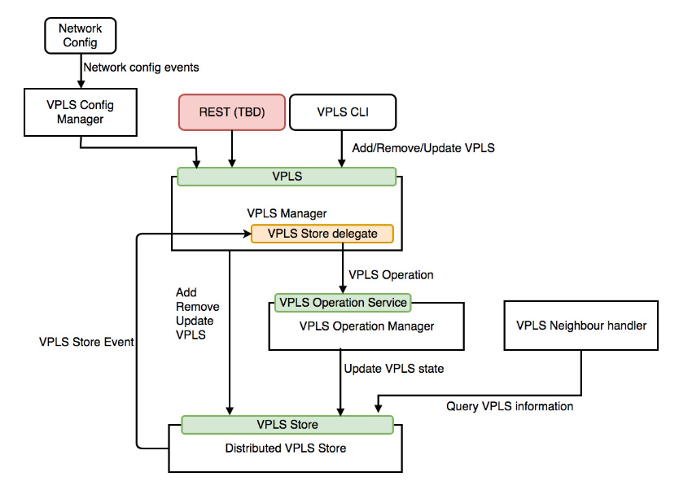

VPLS configuration can be submitted from ONOS CLI or ONOS REST API. When the VPLS configuration is submitted to the VPLS application, it arrives at the VPLS Config Manager. Any host event information such as removal or addition of any host in the network is taken care by the VPLS Config Manager. The VPLS Config Manager component administers the update events of ONOS network configurations and optimizes changes from VPLS network config event to invoke VPLS API. This VPLS API is provided by the VPLS Manager for managing VPLS. The API provides create, update, read and delete functionality. VPLS Manager also helps other application to interact with VPLS Store and VPLS Operation Manager. It is also responsible for handling the host events such as attach or detach of hosts from the VPLS network. VPLS Manager component contains another component in itself named, VPLS Store Delegate. This component is responsible of handling the VPLS store events and generate new VPLS operations according to the store event type and VPLS status. After generation of an operation, it is forwarded to VPLS Operation Manager directly. The VPLS Operation Manager manages modification of all operations for VPLS. It converts the VPLS operations to sets of Intent operations and provide correct order of Intent operations. On completion or failure of VPLS operation, it updates the success or error status to VPLS Store. The VPLS Store component stores all VPLS information and transfers VPLS information to network config system. VPLS Neighbour Handler handles the neighbour messages of any VPLS from every interface. [8] This is the general workflow of VPLS application for managing and controlling the VPLS network.

The use case was tested for VPLS network configuration by both the configuration methods, through ONOS CLI and through ONOS REST API. Both the configuration methods were successful in configuring the VPLS network as desired. For the configuration through REST API, the configuration file in JSON format named, ***network-cfg-vpls.json*** is created. The following figure shows the snippet of the configuration file.



The switchports were configured with the appropriate host (end-point) names and their respective MAC addresses. VPLS application named, **org.onosproject.vpls** was configured under the apps argument along with list of VPLS IDs. If VLAN IDs are also used in the VPLS network to distinguish end-points, VLAN IDs can also be configured under each switchport. To set up the VPLS network for this use case, two different VPLS were created with VPLS ID-1 (VPLS 1) and VPLS ID-2 (VPLS 2). The end-points, H1’s and Server2’s interfaces were configured into VPLS 1 and the end-points, H2’s and Server1’s interfaces were configured into VPLS 2 as seen in the above figure. If any encapsulation method is used in the VPLS network, encapsulation type can be defined under each VPLS IDs.

If ONOS controller is downloaded as a source code, after placing VPLS application files in appropriate directory, it needs to be built again. Whereas, if the ONOS controller is downloaded and installed as a package, network-cfg-vpls.json file needs to be transferred to the server using the cURL specifying the location of file on local machine as shown below.

*curl -X POST -H "content-type:application/json" http://192.168.0.114:8181/onos/v1/network/configuration -d @/opt/onos/config/network-cfg-vpls.json --user onos:rocks*

Another VPLS configuration method tested in this use case was configuration through ONOS CLI. ONOS CLI provides commands to set up VPLS network through its command line interface. Note that these commands are not available by default and are required to install and activate along with the VPLS application.

To begin with switchports configuration, the **interface-add** command is utilized along with arguments defining the Open vSwitch’s ID and port number and name of the end-point connected to that switchport. Four switchports as discussed earlier in this chapter were configured through the ONOS CLI as seen in the following figure.



The VPLS command on ONOS CLI provides various options for configuration and management of VPLS network. These options are *create, list, set-encap, clean, delete, add-if* (adding interface)*, rem-if* (removing interface)and *show.* First the VPLS are created with appropriate VPLS IDs and then the relevant switchport interfaces are configured into the VPLS IDs. The *set-encap* command provides the option for configuring the encapsulation type used for that VPLS ID. Likewise other commands can be used to modify or remove the component from the VPLS network. The *vpls list* and *vpls show* commands are used to check the VPLS configuration and status as seen in the following figure.



The configuration method from ONOS CLI does not provide the option to configure the MAC addresses of the end-points. MAC address being the vital entity for this L2VPN service, VPLS application may sometimes won’t be configured correctly if MAC addresses are mismatched. Due to rigorous use of same ONOS controller and same Open vSwitches having same MAC addresses for various use cases, it was observed that the ONOS CLI method of configuration was configuring random MAC addresses to the end-points. Therefore, it was identified that ONOS REST API configuration method was more successful in configuration of successful VPLS network compared to the configuration through the ONOS CLI method.

The successful configuration of the VPLS network results in creation of intents on the VPLS network as discussed earlier in the chapter. These intents further generates some flow rules in the flow tables of involved Open vSwitches. According to the working of VPLS network in this use case, four flow tables (incoming & outgoing of broadcast messages and incoming & outgoing of Unicast messages) were configured on each involved Open vSwitch. The following figure displays these four flow rules generated on the Open vSwitch-1 in the created VPLS network.



Finally the working of created VPLS network was tested from the end-points. The successful configuration and implementation of the VPLS network can be observed through the endpoints CLI as seen in the following figures. The end-points configured in the same VPLS IDs were able to send traffic to each other while the traffic was not reaching to the end-points configured in another VPLS IDs. (Highlighting colours of traffic are in corresponding to the red and blue VPLS IDs in **Figure.#**)



Figure 4. 2 End-points connected in VPLS 1 were successfully sending traffic to each other



Figure 4. 3 End-points connected in VPLS 2 were successfully sending traffic to each other

Hence, the VPLS network configuration was successfully carried out through a single REST API in ONOS controller. While legacy technologies require the manual configuration of multiple devices in the network, SD-VPLS tries to make the process easier for network operators.

## Use Case-2: Testing the Network with Multiple ONOS Controllers

Software-defined networks with single centralised point of controlling the network were facing the major problems of efficiency, scalability, high availability, redundancy and security. [9] These challenges asked the network designers to implement the multi controller architectures. For multi controller architectures, physically distributed architecture with different types was proposed, such as logically centralised and logically distributed architectures and flat and hierarchical architectures.

In physically distributed network architecture, as name suggests the controllers are located at different physical location which further increased the network scalability. This architecture also defined the controller aspects like how to place controllers and which type of communication to use among them. A logically centralised type of architecture means to distribute the control authority among the controllers that they appear as a single controller for the underlying network. All the controllers have the complete view of the network and are responsible of the same tasks in the network. In a logically distributed type of architecture, the controllers are physically and even logically distributed. Unlike controllers of logically centralised architecture, the controllers in logically distributed architecture are responsible for controlling the network devices present in their own scope of network. [2]

The flat and hierarchical type of architectures define the aspects of the control plane. In a flat type of architecture, all the controllers are placed on just one layer having just one layer of control plane. All the controllers have the complete view of the network and are responsible of the same tasks in the network. In flat architecture, the network provides more resilience to failures but the task of managing all the controllers becomes difficult. In a hierarchical type of architecture, the controllers are arranged in multiple layers having two or three layers of control plane. [2] Here the controllers have different sectional view of the network that there are responsible for controlling.

ONOS controller supports the physically distributed and logically centralised type of architecture. ONOS is built to tackle the problems of scalability, high-availability and performance. ONOS’s distributed core relieves the application developers tasks of cluster coordination and state management by offering an available set of core building blocks for dealing with different types of distributed control plane state. [1]

### Introduction

In this use case, a cluster of three ONOS controllers was formed and tested on the network. Single instance of ONOS installed on a virtual machine consumes lot of resources (RAM of 3-4 GB and minimum 3 CPUs), and due to limited availability of resources on the host machine, implementation of this use case was not possible using the standard installation process. Hence, the ONOS controllers were installed on the Docker containers for this use case. Three Docker instances were created to build the cluster of three ONOS controllers. The network of Open vSwitches was created using the Mininet emulator.

ONOS was built to deploy the collection of servers that can communicate with each other to perform the same tasks, distribute responsibilities and control the same network. The physically distributed and logically centralised architecture of ONOS answers the problems of network scalability and high availability. The distributed ONOS environment provides the fault-tolerance and resilience even if a controller instance from the cluster fails.

ONOS controllers cluster is formed on the Atomix cluster. An Atomix framework is designed for implementation of scalable networks and fault-tolerant distributed systems. [10] An Atomix cluster is responsible for ONOS controllers cluster management, data storage and service discovery. [11] The detailed information of downloading and installing Atomix as well as ONOS Docker can be found on ONOS wiki page. [12] After installation and initiating the Docker instances for Atomix and ONOS containers, appropriate configuration for each Docker instance is required to be performed. This configuration should be corresponding to the number of nodes running in the ONOS controllers cluster formed. For instance, if cluster is formed of five ONOS controllers, five different configuration files would have to be created. Similarly, if cluster is formed of three Atomix instances, three different configuration files would have to be created. The number of ONOS controllers in a cluster and the number of Atomix instances in a cluster must be always be equivalent, but it is recommended to have at least three of each instances in their respective clusters.

The configuration files of Atomix instances are named corresponding to the name of Atomix Docker containers are as shown in the following figure. These configuration files are required to be installed on all running docker instances for Atomix cluster.



The cluster configuration in Atomix configuration file specifies the details about all the nodes of Atomix instances running in the cluster. Since ONOS functions on Raft protocol for cluster formation, this protocol must be defined in the management-group for managing the Atomix cluster. The partition-groups lists the members of the cluster, storage level and number of partitions. ONOS recommends to make partition group of twice the number of Atomix nodes present in the cluster. [13] The configuration files of ONOS controllers are named corresponding to the name of ONOS controller Docker containers are as shown in the following figure. These configuration files are installed on individual running docker instance for ONOS controllers cluster.



Since, the ONOS controllers cluster creation and management is handled by the Atomix framework, the ONOS cluster configuration files contains just the information about Atomix cluster. On initiation of ONOS instance in the network, the location is informed to the Atomix. The *Atomix group membership* primitive is used to determine the changes of initiation or failure of any ONOS controller. Atomix then informs the other ONOS instances about the new ONOS instance via Atomix cluster. ONOS instances connect to each other and share the information about underlying network through the peer-to-peer communication.

On successful installation and configuration of both, Atomix and ONOS controllers are formed and the details can be checked from the ONOS GUI as seen in the following figure.



In this use case, cluster of three Atomix instances with group of 7 partitions was created as seen in the above figure. The network was controlled by the cluster of three ONOS controllers. For this use case, the underlying network was created in the Mininet environment. A Spine-Leaf topology was deployed consisting of six Open vSwitches and 20 hosts.

In the following figure, three ONOS controllers can be observed in ONOS Cluster Node Panel on ONOS GUI. Three ONOS controllers are displayed in three different colours (navy blue, blue & red) having three different IP addresses (172.17.0.5, 172.17.0.6 & 172.17.0.7) respectively.



Figure 4. 4: ONOS controllers cluster view on the ONOS GUI

ONOS controllers cluster formed here is physically distributed (different IP locations) and logically centralised (controlling the same network), which proves the distributed type of architecture discussed earlier in this chapter. Cluster of these ONOS controllers acts together as a unified and coherent distributed system. The six Open vSwitches are equally distributed among the three ONOS controllers. The switches have chosen a master controller for themselves by process explained in next sub-chapter.

The details about the ONOS controllers cluster can be found under Cluster Nodes tab on ONOS GUI as shown in the following figure. The ONOS controllers communicate with each other using the TCP port number mentioned in the ONOS controllers cluster formation configuration files.



Figure 4. 5: Cluster Nodes of three ONOS controllers

### Master Controllers with their Devices

The ONOS controller refers to the Open vSwitches as Devices. The switches connected in the network are open to choose a master controller for themselves from the available controllers in the cluster. A switch can have one and only one master controller, whereas a master controller can have multiple switches associated with itself. The function of master controller is to read and write the control instructions on the associated Open vSwitches. If the associated master controller shuts down, ONOS elects a new master from the remaining available controllers that the switch can communicate with.

All the ONOS controllers present in the cluster are able to track the state of all Open vSwitches in the network. A controller can be associated with any role out of three roles defined by the OpenFlow. These role can be Master role, Standby role or None role.

1. A Master role of controller has full control over the switch and can read and write instructions on that switch.
2. A Standby role of controller has partial control over the switch and can only read instructions from that switch.
3. A None role of controller cannot read instructions from the switch and may or may not know the switch in the network.

When the new switch is connected in the network, all the controllers present in the cluster start collecting information from that switch. The first controller to collect the information that none of the controller is associated master to that switch and setup a control channel with that switch, becomes a master controller for that switch. Other controllers that discover this switch later are given the Standby role. If any switches are shut down or lose connection in the network, the controller is associated with the None role.

The following figure shows the list of devices (Open vSwitches) connected in the network with their respective Master controller.



Figure 4. 6: List of Open vSwitches with their associated Master controller

If any master controller is shut down or losses connectivity from the network, a new master is elected for the switches, which were associated with that master controller. A new master is elected from the list of Standby role controllers for that individual switch. This list of Standby controllers is arranged according to the Node IDs of controllers in preference order. This enables switch to elect next best master controller in case of failure of current master controller.

The following figure shows the failure of one controller and re-election of new master controller for the switches. In the created network, a controller (172.17.0.5) was explicitly shut down and it was observed that the switches associated with that controller re-elect the new master controller (172.17.0.6).



Figure 4. 7: Failure of one controller from the cluster

### Proof and validation of Link failover functioning

Previous chapters discuss about the failure of controller and devices in the network, this sub-chapter will discuss about the failure of link between the devices.

The links between the devices are discovered on a hop-by-hop basis by using probe frames. The probe frames are forwarded from all ports of device containing device ID. The other end of link is discovered when the other device on other end receives this probe frame and sends it back to the controller. The *Link subsystem* of ONOS communicates with *Device subsystem* using the *LLDPLinkProvider*. The LLDPLinkProvider’s *LinkDiscovery* object performs link discovery through LLDP messages. [14] After the links are discovered, the data transmission between the devices takes place mostly via Reactive Forwarding.

The Reactive Forwarding concept of SDN enables the controller to configure the path between the devices when the actual data has been transmitted from either of the device. ONOS contains an application named ***org.onosproject.fwd*** which is required to be installed and activated for data transmission to take place in the network. When the end-points generate some traffic in the network, the first packet is encapsulated as a PacketIn message of OpenFlow and forwarded to the ONOS controller. With the help of Reactive Forwarding application, ONOS controller updates the flow rules on the Open vSwitches. It uses the Dijkstra algorithm for finding the best possible path between the end-points. [15] The use of Intent based service in the network increases the resilience of the network.

The Intents are managed by the Intent subsystem which is explained in detail in chapter 4.2.3. The Intent subsystem acquires the information and updates about the network topology from the Topology subsystem. When the new Intents are formed between the end-points, the Intent subsystem creates the path between the end-points based on the information received from the Topology subsystem. In case of link failure which is part of Intent path, the Intent subsystem makes changes in the path based on the information received from the Topology subsystem. The controller expects the link failure information to be transferred to it through the control messages of OpenFlow protocol. On receiving this information, the Intent subsystem decides either the creation of new intents or updating the affected intents in the network. [16] This information is further results in changes in flow rules of the Open vSwitches.

In this way when a link between the Open vSwitches is shut down, ONOS detects this events and the information about the updated paths is forwarded to the Open vSwitches. To test this mechanism, the created network environment for the multiple controller use case was utilized. An intent was created between the end-points (10.0.0.2 and 10.0.0.18) as seen in the following figure.



The created intent was able to find the best shortest path between the selected end-points through Leaf1-Spine1-Leaf4 path as seen in the above figure. One of the link which was part of this path, link between the Spine1 and Leaf1 was manually shut down using the mininet command. The ONOS controller was successful for installing the new intent and updating the revised flow rules on the Open vSwitches.



The above figure shows the installation of new path via Leaf1-Spine2-Leaf4 Open vSwitches. The same process was repeated again and another link which was part of this path, link between the Spine2 and Leaf4 was manually shut down using the mininet command. And the ONOS controller was successful for installing again the new intent and updating the revised flow rules on the associated Open vSwitches.



The above figure shows the installation of new path via Leaf1-Spine2-Leaf2-Spine1-Leaf4 Open vSwitches. This shows that intents based service increases the resilience of the network and intents are more powerful than simply installing flows. Hence, proves and validates the link failover mechanism in the network controlled by ONOS controller.

## Use Case-3: Testing the ONOS Controller with IPv6 Addressing

With the introduction of Wi-Fi 6 and 5G, the devices connected to the internet are increasing very rapidly. Studies suggest that the IPv4 addressing scheme, which is base addressing scheme of internet today won’t be able to tackle the problem of exponential increase of devices. The introduction of IPv6 addressing scheme provides the feasible solution for this problem in the current and future generation networking.

The lack of IPv4 addresses forces the Internet Service Providers (ISPs) to migrate to the IPv6 addressing scheme. Numerous aspects are taken into consideration such as optimum cost of migration, security, quality of service, monitoring, device configurability of vertically integrated switches and routers. Software-defined Networking with its concept of centralised controlling and managing the network, promises to ease this migration to IPv6 addressing scheme with possibility to reduce human errors to benefit the new generations of networking. SDN also enables the programmable networking and introduces the open standards which help ISPs to move out of specific vendor lock-ins.

While SDN increases the controllability of networking devices through programming and virtualization using open protocols, IPv6 improves the efficiency of the internet protocol as a whole, including routing. A software-controlled IPv6 network is required to replace the already used IPv4 addresses to answer the convergence in telecommunications focusing towards the migration to latest generation digital packet based communications. However, it is not feasible to immediately migrate the current network to SDN and IPv6-based networking. The migration is a gradual process, thus in order to ensure a seamless transition, a good plan must be developed that considers consumer demand, capital and operating expense and traffic engineering. [17]

### Introduction

IPv6 was introduced in OpenFlow version 1.2 and OpenFlow version 1.3 added some new IPv6 features. IPv6 address mechanism is supported by ONOS platform since version Blackbird 1.1.0. IPv6 feature is explicitly required to be configured on the ONOS controller. For activating IPv6 on ONOS controller, following configurations and applications are required to be installed and activated through ONOS CLI or ONOS GUI.

**Applications:**

|  |  |
| --- | --- |
| 1. Proxy ARP | APP ID: org.onosproject.proxyarp |
| 1. Reactive Forwarding | APP ID: org.onosproject.fwd |
| 1. IPv6 RA (Route Advertisement) Generator | APP ID: org.onosproject.routeradvertisement |
| 1. Host location Provider | APP ID: org.onosproject.hostprovider |

**Configurations:**

|  |
| --- |
| ***HostLocationProvider component*** |
| onos> cfg set org.onosproject.provider.host.impl.HostLocationProvider requestIpv6NdpRsRa true |
| onos> cfg set org.onosproject.provider.host.impl.HostLocationProvider requestIpv6ND true |
| ***NeighbourResolutionManager component*** |
| onos> cfg set org.onosproject.net.neighbour.impl.NeighbourResolutionManager ndpEnabled true |
| ***IPv6 Reactive Forwarding component*** |
| onos> cfg set org.onosproject.fwd.ReactiveForwarding ipv6Forwarding true |
| onos> cfg set org.onosproject.fwd.ReactiveForwarding matchIpv6Address true |

The detailed steps for enabling IPv6 addressing scheme on ONOS controller mentioned here [18] are outdated.

For testing the ONOS controller functionality with the IPv6 addressing this use case was implemented. In this use case, the network was created consisting of four Open vSwitches and four end-points (hosts) in the GNS3 emulation software. The network was simultaneously tested for both IPv6 and IPv4 addressing scheme. The NAT interface was used to connect the Open vSwitches with the ONOS controller which was installed and running on VM outside the GNS3 environment. All the software versions are same as mentioned in **Table.#** The following figure shows the implemented network consisting of four end-points, two end-points (H1 and H4) just using IPv6 addressing scheme and two end-points (H2 and H3) using both IPv6 and IPv4 addressing scheme.



*Topology created in the GNS3 with different Network devices*

After successful configuration and booting up the network in GNS3 software, ONOS controller was able to identify the IPv6 end-points in the network. The following figure displays the view of created network from the ONOS GUI.



As seen in the above figure, the ONOS controller accurately identifies both the IPv6 and IPv4 addressing schemes and also Link-local and Global Unicast IPv6 addresses for all the end-points.

When any new IPv6 data packet arrives at the any switchport for the first time, Open vSwitch sends the Neighbour Solicitation packet to the ONOS controller. The Neighbour Solicitation packet contains the Target Address (TA) of the IPv6 data packet. ONOS controller forwards this Neighbour Solicitation packet to all the connected Open vSwitches in the network. The Open vSwitch, which is connected to end-point of the mentioned Target Address (TA) send back the Neighbour Advertisement packet to the ONOS controller mentioning that requested Target Address (TA) is connected to itself. ONOS controller forwards this Neighbour Advertisement packet to the Open vSwitch which generated the Neighbour Solicitation packet.

The Neighbour Discovery of IPv6 addresses on ONOS controller was captured in the network using the Wireshark application. The ICMPv6 pings were forwarded in the network and subsequently related packets were captured.

In the following **figure.#** the sequence of packet transmission in the network is displayed. Source and destination end-points (H1 and H4) of ICMPv6 packet, all Open vSwitches and the ONOS controller nodes are listed at the top of the figure along with their IP addresses. (Note: the IP addresses of Open vSwitches are the addresses of eth0 management interface connected with the ONOS controller). All the transmissions are numbered according to the sequence of occurrence. The packets exchanged between end-points and Open vSwitches are highlighted in red colour, the packets exchanged between Open vSwitches and ONOS controller are highlighted in blue colour and the packets exchanged between Open vSwitches are highlighted in green colour. The Neighbour Solicitation and the Neighbour Advertisement packets contains the Target Address (TA).



The ICMPv6 data packets were transmitted in this use case. The ICMPv6 request packet was generated between the end-points H1 (IPv6 address: 2001::1001) and H4 (IPv6 address: 2001::1004) containing Source Address: 2001::1001 and Destination Address: 2001::1004. This ICMPv6 request packet was forwarded to eth4 interface of Open vSwitch-1. Since the Open vSwitch-1’s flow table doesn’t have any rule for this IPv6 address, the Open vSwitch-1 sent the Neighbour Solicitation packet to the ONOS controller containing the Target Address (TA) of the H4. ONOS controller forwarded this Neighbour Solicitation packet to all the connected Open vSwitches in the network. The Open vSwicth-4 generated the Neighbour Advertisement packet mentioning that requested Target Address (TA) of H4 is connected to itself and send this packet to the ONOS controller. ONOS controller forwards this Neighbour Advertisement packet to the Open vSwitch-1.

Since the IPv6 packet of new type (ICMPv6 request) had arrived at the switchport, the Open vSwitch-1 forwarded the ICMPv6 request packet encapsulated in OpenFlow packet type OFPT_PACKET_IN to the ONOS controller. The ONOS controller sent the OpenFlow packet type OFPT_PACKET_OUT to the Open vSwitch-1 containing information to forward the ICMPv6 request packet from port 3 (eth3 interface). Also the flow rule was listed in the flow table of Open vSwitch-1 for this destination address of H4. The Open vSwitch-1 forwarded the ICMPv6 request packet to the Open vSwitch-4. The Open vSwitch-4 also didn’t had any flow rules for this destination address and it forwarded ICMPv6 request packet encapsulated in OpenFlow packet type OFPT_PACKET_IN to the ONOS controller. The ONOS controller sent the OpenFlow packet type OFPT_PACKET_OUT to the Open vSwitch-4 containing information to forward the ICMPv6 request packet from port4 (eth4 interface). Also the flow rule was listed in the flow table of Open vSwitch-4 for this destination address of H4. The Open vSwitch-4 forwarded the ICMPv6 request packet from the port 4 to the end-point H4. H4 generated the ICMPv6 reply packet containing Source Address: 2001::1004 (H4) and Destination Address: 2001::1001 (H1).

After this packet arrived at Open vSwitch-4, Open vSwitch-4 checked its flow rules and didn’t find any flow rules listed for the destination address of H1 and the packet was forwarded to the ONOS controller. ONOS controller replied back to forward the ICMPv6 reply packet from port 1 and updated the flow rule for this destination address on the Open vSwitch-4. Same process was done by the Open vSwitch-1 when the ICMPv6 reply packet arrived at its switchport.

Flow rules were listed for both the destination addresses of H1 and H4 on both the Open vSwitches. When the next ICMPV6 request packet arrived at the Open vSwitch-1 for the destination of H4, the flow rule was found for this destination address and the packet was directly forwarded to Open vSwitch-4.

The following figure displays the discussed packet transmission captured on the Wireshark application. These packets were captured just between the Open vSwitches and ONOS controller and therefore doesn’t contain packets transmitted between end-points and Open vSwitches and also packets transmitted between the Open vSwitches. The packet numbers are corresponding to the packet numbers in **figure.#**



The Reactive Forwarding application enabled with IPv6 forwarding and matchIpv6Address component takes care of installing the flow rules on Open vSwitches when the IPv6 packets are transmitted in the network. These flow rules are installed on Open vSwitches on temporary basis and are removed when the data transmission stops. If the IPv6 packets are again transmitted in the network for the same end-points, the flow rules are again updated on the Open vSwitches without performing the Network Discovery. This minimises the bandwidth utilisation by the control messages in the network.

The alternative to this is installing Intents between the end-points which further update the flow rules on Open vSwitches. This method installs the flow rules permanently on Open vSwitches saving the time taken for Neighbour Discovery but on the other hand increase the bandwidth utilisation by the control messages in the network.

### IPv6 over IPv4 tunnelling

One of the major problem faced by ISPs while migrating the network from IPv4 to IPv6 addressing scheme is integrating the IPv6 subnets with IPv4 subnets. Migrating a IPv4 addressing network to IPv6 addressing is not a single step process. The migration takes place in specific stages, beginning with developing small subnets of IPv6 addresses within the IPv4 network and progressively transferring all the services to IPv6 in the network. But during this transition, the IPv6 subnets should be able to communicate over the IPv4 infrastructure. The IPv6 subnets can be configured to transmit packets over IPv4 network by *IPv6 over IPv4 tunnelling.* IPv6 over IPv4 tunnels are point-to-point tunnels created by encapsulating IPv6 packets within IPv4 headers to carry them over IPv4 network.

In this use case, another network was implemented in GNS3 environment to test the functioning of ONOS controller for IPv6 over IPv4 tunnelling. The isolated IPv6 subnets were created and IPv4 network was configured between these subnets. The Open vSwitches and ONOS controller were located in the IPv4 network. The Cisco routers (Cisco IOS Software, 7200 Software (C7200-ADVENTERPRISEK9-M), Version 12.4(24)T5) were utilized to configure the IPv6 over IPv4 tunnels.

The following figure displays the created network in the GNS3 environment. Two isolated IPv6 subnets (2010::/112 and 2020::/112) were created containing a Router and an end-point in each subnet. An IPv4 network (highlighted in yellow) consisting of four Open vSwitches and connecting to the ONOS controller through NAT interface was created between these IPv6 subnets. The IPv6 over IPv4 tunnel was configured between the Router R1 and Router R2.



*Topology created in the GNS3 with different Network devices*

The installation of required applications and configurations for enabling IPv6 was done on the ONOS controller. The tunnel interfaces were configured with the IPv6 address 3000::1/112 at router R1’s interface g0/0 and 3000::2/112 at router R2’s interface g0/0. Tunnel mode 6to4 (ipv6ip) and RIP routing protocol was configured to advertise the IPv6 addresses through the tunnel. The following snippet shows the Tunnel interface configuration on router R1.



After successful configuration of tunnel and enabling IPv6 services on ONOS controller, ONOS controller was able to set up the IPv6 tunnel over IPv4 network. The following figure displays the view of created network from the ONOS GUI.



The ONOS controller is able to identify only the immediate to non-OpenFlow enabled device connected to OpenFlow enabled device. Therefore ONOS controller just have the information about the IPv4 devices in the created network as seen on the ONOS GUI. The successful installation of tunnel can be confirmed from either of the routers at the end interfaces of tunnel.

The following figure shows the IPv6 routes to IPv6 subnet located at the other end of the tunnel has been successfully advertised over the tunnel and learned by the router R1 through RIP routing protocol.



The following figure show one of the packet captured by Wireshark application between the Open vSwitch-1 and ONOS controller on the IPv4 network.



The successful creation and installation of IPv6 tunnel over IPv4 network can be seen in the above figure. The IPv6 data packets are encapsulated in the IPv4 packets and transferred over the tunnel. OpenFlow protocol encapsulates the tunnel packets in itself to inquire the ONOS controller about forwarding of the packets. The ONOS controller also replies back with the encapsulated OpenFlow packet containing appropriate actions to be taken to forward the packet (basically containing information from which switchport to forward the packet). The above figure displays one such reply packet from ONOS controller to the Open vSwtich-1 containing the information to forward the ICMPv6 reply packet from the port 3.

ONOS controller with its available features, is compatible with various services of IPv6 addressing scheme and can benefit the migration of IPv4 networks to the IPv6 networks.

## Use Case-4: Integrating Software-defined Network with the Legacy Networks

After evaluating various aspects of SDN through ONOS controller, concluding chapter was to evaluate the process of integrating Software-defined network with the legacy networks consisting of coupled control and data plane network devices.

The legacy networks consist of several Autonomous Systems (AS) and are mostly heterogeneous in nature which leads to the problem of multi-domain heterogeneous network migration planning. Implementing Software-defined network with the legacy network comes with other challenging problems like lack of a high maturity level of SDN-based standards, insufficient availability of skilled human resources, technical as well as business perspectives, higher costs of network migration to replace or upgrade network devices. Due to these reasons, most of the ISPs evade the idea to migrate to technologies like IPv6 and SDN.

However to overcome the management and controlling issues of legacy networks, SDN is the feasible solution. The migration can be kicked off by first transferring the Private customer networks into the SDN and later gradually implementing SDN in core Public networks. In the Public networks, the migration can be initiated by setting up hybrid networks of legacy networks with SDN and eventually transferring the network completely into SDN. [19]

### Introduction

ONOS controller is developed to support the migration of legacy networks to the SDN. ONOS controller is capable of performing and exchanging the routing information with the legacy routers using the SDN-IP application. SDN-IP is an ONOS application developed and implemented over ONOS controller to connect to the external networks on the legacy networks using the standard Border Gateway Protocol (BGP). The SDN network acts as an Autonomous System (AS) to the legacy routers in the network. The SDN network consists of Open vSwitches, ONOS controller and BGP Speakers. BGP Speakers are used to establish the peering with the external gateway routers by acquiring route information from the ONOS controller. This configured SDN network serves as a transit network communicating with other legacy networks.

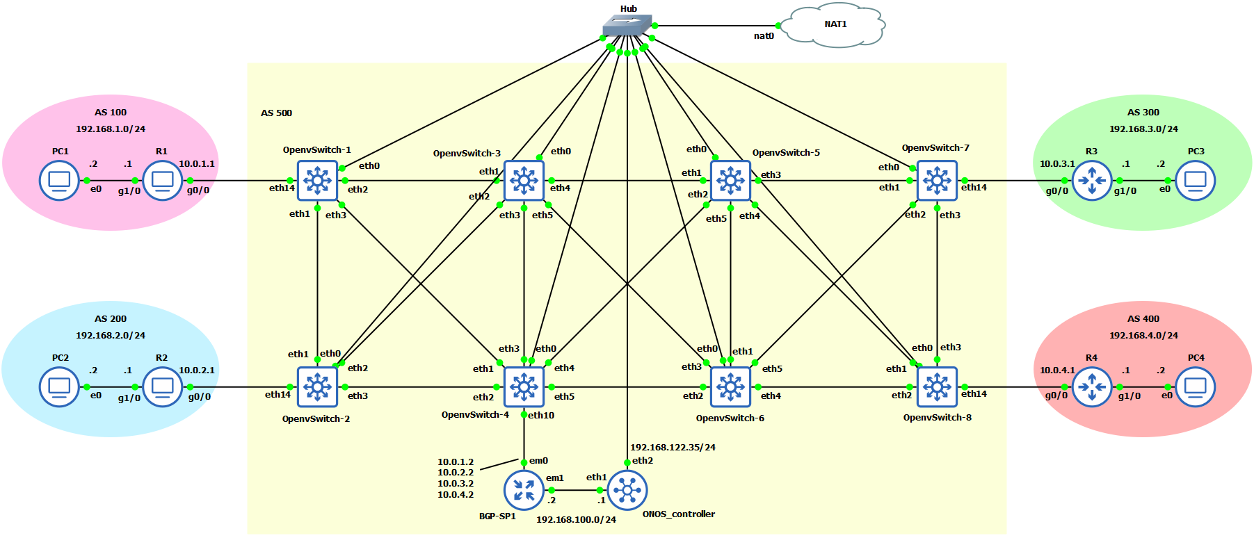In this use case SDN network was implemented in the GNS3 network emulator consisting of 8 Open vSwitches, one BGP speaker and the ONOS controller. The ONOS controller was running inside the GNS3 emulator in this use case to set up the iBGP peering with the BGP speaker. The eth0 management interfaces of all Open vSwitches were connected to the ONOS controller through Hub and Hub was connected to NAT interface so that ONOS controller can access internet. Four different Autonomous Systems were implemented, each with one border gateway router and a host PC. The following figure displays the implemented network in GNS3 emulator.

*Topology created in the GNS3 with different Network devices*

To test the integration process of SDN network with the legacy networks through ONOS controller, this use case was created consisting of five different AS. Four IPv4 legacy networks were created, AS 100 with border gateway router R1, 200 with border gateway router R2, 300 with border gateway router R3 and 400 with border gateway router R4. The Cisco routers (Cisco IOS Software, 7200 Software (C7200-ADVENTERPRISEK9-M), Version 12.4(24)T5) were utilized as border gateway routers for these legacy networks. The SDN network was created in separate AS 500 consisting of 8 Open vSwitches and BGP Speaker (BGP-SP1). The BGP Speaker was implemented on Quagga suite [20] on FreeBSD platform [21] version clang 8.0.1 working with FRRouting (version 7.2) [22] open source Internet routing protocol suite. The Open vSwitches and ONOS controller’s specifications are as listed in the **Table.#**

The border gateway routers were configured with BGP to share the routing information of their respective internal networks. These border gateway routers peer with BGP Speaker in the SDN network and use eBGP to exchange routing information with the adjacent external network routers through BGP Speaker. Due to limited memory resources availability on the host machine, only a single BGP Speaker was implemented in the SDN network, however multiple BGP Speakers can be implemented to increase the high availability of the network. The BGP Speaker use iBGP to communicate with the other BGP Speakers and SDN-IP application on ONOS controller. The routes advertised by the border gateway routers to the BGP Speaker are processed and re-advertised to the other external networks by the BGP Speaker with the help of SDN-IP application. The best route for each destination is decided by the SDN-IP application according to the standards of iBGP and translated into an ONOS Application Intent Request. ONOS converts the Application Intent Request into forwarding flow rules on the connected Open vSwitches in the network. These flow rules are utilised by the switches to exchange the traffic between the legacy networks.

The SDN-IP application offers the integration mechanism of BGP to the ONOS controller. It behaves as a regular BGP speaker, at the protocol level. For ONOS controller, SDN-IP is just an application that uses its services to install and update the appropriate forwarding flow rules on the Open vSwitches. The SDN network created in this use case acts as a transit AS in between the deployed legacy networks. From external border router gateway’s point of view, the created SDN network is just an another normal AS.

The following figure displays the topology view of the configured network in this use case, perceived from the ONOS GUI. As seen in the figure, the ONOS controller successfully identifies the configured IP addresses on each external border routers of legacy networks and also the configured BGP speaker deployed in the created SDN network.

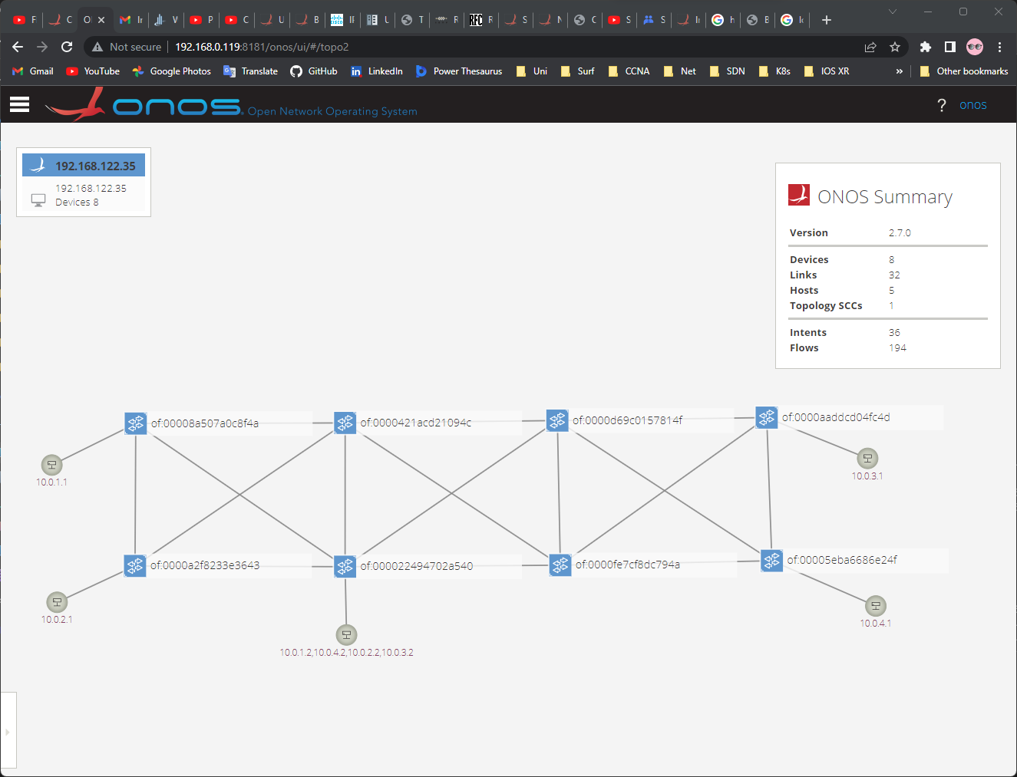

*Topology view on the ONOS controller GUI*

### Configuration and Working

For accurate functioning of the SDN-IP application, it requires some configuration to be set up on the ONOS controller. The configuration file, named *network-cfg-bgp.json* was created containing the exact location of external BGP border routers and the BGP speaker. The appropriate BGP peering addresses are required to be configured at the switchport connecting to the border router. The complete configuration file can be found in the Appendix. BGP speaker also needs to be configured with the eBGP peering addresses to the border routers. To peer BGP speaker with ONOS controller, iBGP configuration at port 2000 is done so that speaker can share routes with the ONOS controller. Similarly, all the border gateway routers are configured to peer with the BGP speaker and advertise their internal networks.

The Quagga BGP speaker was configured to enable FRRouting and single interface (em0) was configured with all eBGP peering addresses for the border routers of legacy networks. The BGP speaker peers in two methods:

* BGP speaker must have connection to the SDN data plane network, through which the BGP speaker can peer with external border routers using eBGP.
* BGP speaker must have direct connection to the ONOS controller, through which the BGP speaker forms iBGP peer with the SDN-IP application. This connectivity for this peering must be out-of-band of the data plane.

For activating SDN-IP application on ONOS controller, following applications are required to be installed and activated through ONOS CLI or ONOS GUI.

*Applications:*

|  |  |
| --- | --- |
| 1. Proxy ARP | APP ID: org.onosproject.proxyarp |
| 1. Reactive Forwarding | APP ID: org.onosproject.fwd |
| 1. Configuration Manager | APP ID: org.onosproject.config |
| 1. SDN-IP | APP ID: org.onosproject.sdnip |

After successful configuration of all the devices in the network, all the legacy routers formed the eBGP peering with the BGP speaker in the SDN network and the routes were exchanged between them. The BGP speaker also formed the iBGP peering with the SDN-IP application and all the routing information was shared with the ONOS controller as seen in the following figure.

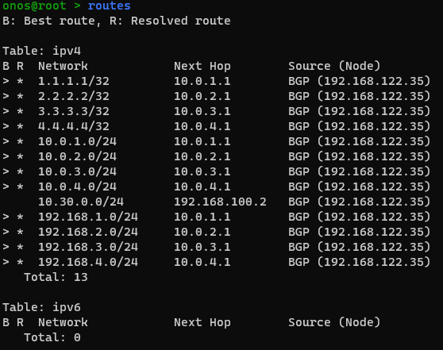

The external border routers advertise the routes of their respective AS to the BGP speaker in the SDN network and further these routes are re-advertised to the other external border routers and the SDN-IP application. The SDN-IP application selects the best route for each destination according to the iBGP standards and these are translated into the ONOS Application Intent requests. ONOS controller translates these Point-to-Point Intent requests into the flow rules, which are further implemented on the respective Open vSwitches. Moreover, Multi-Point-to-Single-Point Intents are created which allows external BGP routers to peer with the BGP speaker. Consequently, BGP itself can also detect failures and act accordingly in case of any link failure.

The following figure displays the part of Intents created by the ONOS Intent subsystem.

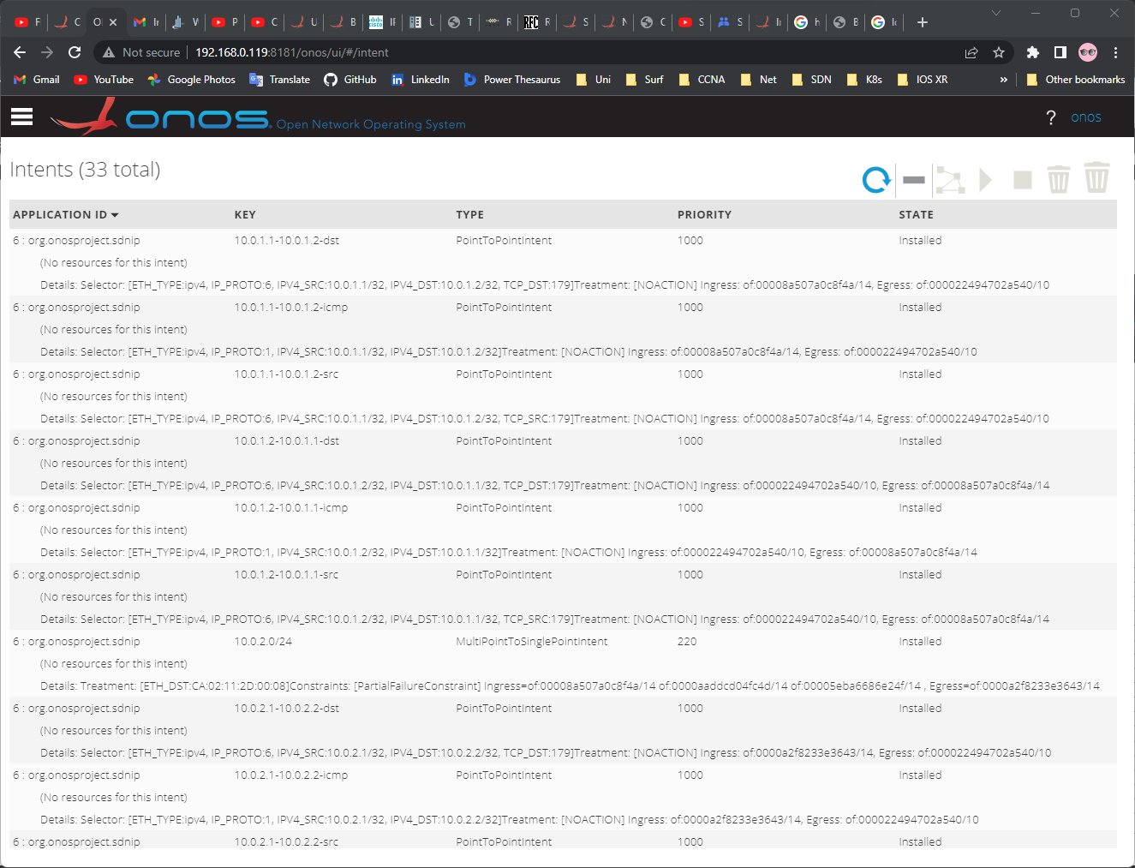

Along with multiple BGP speakers, multiple ONOS controllers in form of cluster can be implemented to increase the high availability and scalability of the network. In case of implementation of multiple ONOS controllers, number of SDN-IP applications can also be increased. SDN-IP application provides the support for high availability using a hot-standby model. However, among all the SDN-IP applications, only one is active and has he role of Leader application and others are on Standby mode. The ONOS leader election service is utilized by the SDN-IP application to elect the Leader. Each SDN-IP application receives the routing information from the external BGP routers but only the Leader is responsible for creating the Intent requests on all the ONOS controllers. In case of failure of the Leader SDN-IP application, new Leader is chosen from the other available SDN-IP applications on Standby mode. The elected new Leader performs the Intent synchronization to ensure all the Intents are installed as per the current BGP routes learnt.

However, due to limited availability of memory resources on the host machine only a single instance of ONOS controller and a single instance of BGP speaker was implemented for testing this use case. The following figure shows the list of BGP Speakers and BGP Neighbours learnt through iBGP peering with the ONOS controller. The BGP neighbour seen here is BGP speaker (BGP-SP1), configured with BGP ID 10.10.10.10.

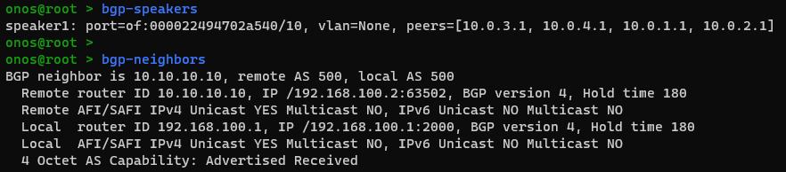

The BGP speaker was able to successfully form the iBGP peering with SDN-IP application and eBGP peering with the external BGP routers as displayed in the following figure. Total of five Neighbours were connected to the BGP speaker, four external BGP routers and one ONOS controller.

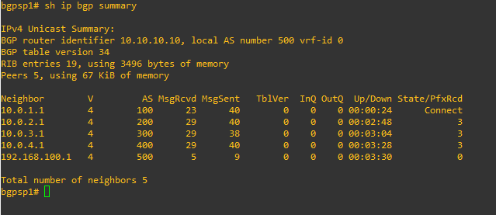

After successful installation and configuration of the SDN network devices, the external routers were able to exchange and learn routes from the other Autonomous Systems. The BGP border routers of each legacy network were configured to exchange the connected internal network and the same can be confirmed from one of the border routers console as seen in the following figure.

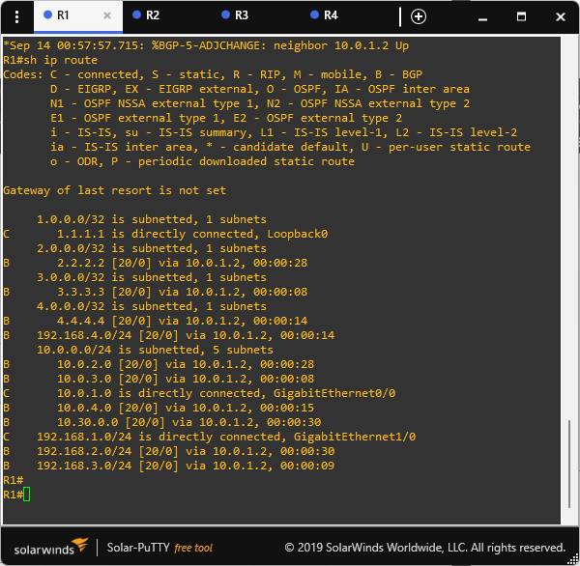

The internal PCs in each AS were configured with border router as their gateway and therefore, all the PCs were able to transfer packets to each other.

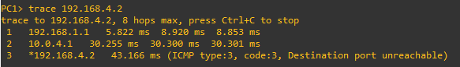

SDN-IP is an application developed and implemented over ONOS to integrate SDN and legacy networks in terms of routing and interoperability so that service providers can have a gradual migration by smoothly inte-grating SDN with the legacy networks.

(SDN) creates many opportunities to create smart networking with better efficiency for network management and operation.

# Summary and Perspectives

# Abbreviations

**0**

…

**3**

3GPP Third Generation Partnership Project

…

**A**

AS Autonomous System

…

**B**

**C**

**D**

DLUX

**G**

GNS3

**H**

**I**

ISP Internet Service Provider

**L**

**N**

NBI Northbound Interface

NetConf Network Configuration Protocol

**O**

ONF Open Networking Foundation

ODL OpenDayLight

ONOS Open Network Operating System

**S**

SBI Southbound Interface

SDN-IP

SNMP Simple Network Management Protocol

…

**V**

VPLS Virtual Private LAN Service

**Z**

…

# References

|  |  |
| --- | --- |
| [1] | B. a. L. R. Team, “Distributed SDN Control: Survey, Taxonomy and Challenges,” *IEEE Communications Surveys & Tutorials,* p. 25, December 2017. |
| [2] | M. B. M. R. B. Othmane Blial, “An Overview on SDN Architectures with Multiple Controllers,” p. 9, 2016. |
| [3] | “OpenFlow Switch Specification Version 1.5.1 ( Protocol version 0x06 ),” *Open Networking Foundation,* p. 283, March 26, 2015. |
| [4] | B. H. N. M. Bob Lantz, “A Network in a Laptop: Rapid Prototyping for Software-Defined Networks,” *9th ACM Workshop on Hot Topics in Networks,* October 2010. |
| [5] | B. Lantz, “Onosproject.org,” 27 January 2017. [Online]. Available: https://wiki.onosproject.org/display/ONOS/Mininet+and+onos.py+workflow. |
| [6] | K. G. A. K. J. G. e. a. K Gaur, “A survey of Virtual Private LAN Services (VPLS): Past, present and future,” *Computer Networks,* June 2021. |
| [7] | M. Liyanage, “Enhancing security and scalability of Virtual Private LAN Services,” University of Oulu, Finland, 2016. |
| [8] | C.-M. O. e. a. Carolina Fernández, “Virtual Private LAN Service - VPLS,” Onosproject.org, 30 May 2017. [Online]. Available: https://wiki.onosproject.org/display/ONOS/Virtual+Private+LAN+Service+-+VPLS. |
| [9] | W. M. L. F. K. Wenjuan Li, “A survey on OpenFlow-based Software Defined Networks: Security challenges and countermeasures,” *Journal of Network and Computer Applications,* p. 14, 2016. |
| [10] | J. Halterman, “Atomix,” 2013. [Online]. Available: https://github.com/atomix/atomix. |
| [11] | J. H. e. a. Luca Prete, “Forming a cluster,” Onosproject.org, [Online]. Available: https://wiki.onosproject.org/display/ONOS/Forming+a+cluster. |
| [12] | Y.-F. L. Eric Tang, “Notes on cluster formation for Docker instances,” Onosproject.org, 2022. [Online]. Available: https://wiki.onosproject.org/display/ONOS/Notes+on+cluster+formation+for+Docker+instances. |
| [13] | J. Halterman, “ONOS Cluster Configuration,” Onosproject.org, 2018. [Online]. Available: https://wiki.onosproject.org/pages/viewpage.action?pageId=28836788. |
| [14] | S. Wu, “Network Discovery,” Onosproject.org, 2016. [Online]. Available: https://wiki.onosproject.org/display/ONOS/Network+Discovery. |
| [15] | R. Eddy, “Multicast Use Case,” Onosproject.org, 2015. [Online]. Available: https://wiki.onosproject.org/display/ONOS/Multicast+Use+Case. |
| [16] | G. M. S. A. C. R. R. H. E. M. Dimas A. Marenda, “Intent-Based Path Selection for VM Migration Application with Open Network Operating System,” Institut Teknologi Bandung. |
| [17] | D. B. R. P. M. Babu R. Dawadi. Shashidhar R. Joshi, “Towards Smart Networking with SDN Enabled IPv6 Network,” 2022. |
| [18] | D. P. K. I. P. R. Charles Chan, “How to Enable IPv6,” Onosproject.org, January 2017. [Online]. Available: https://wiki.onosproject.org/display/ONOS/IPv6#IPv6-HowtoEnableIPv6. |
| [19] | D. B. R. S. R. J. a. P. M. Babu R. Dawadi, “Legacy Network Integration with SDN-IP Implementation towards a Multi-Domain SoDIP6 Network Environment,” *electronics,* 2020. |
| [20] | “Quagga Routing Software Suite,” [Online]. Available: https://www.nongnu.org/quagga/index.html. |
| [21] | “BSD Router Project: Open Source Router Distribution,” [Online]. Available: https://bsdrp.net/BSDRP. |
| [22] | “FRRouting Project,” [Online]. Available: https://frrouting.org/. |

# Appendix

IPv6 Neighbour discovery packets









IPv6 tunnelling over IPv4





SDN-IP

